

Texas Regional Collaboratives for Excellence in Science & Mathematics Teaching

The University of Texas at Austin

Please notice that payments will arrive no sooner than three weeks after submission of materials.
Payee First Name
Payee Last Name
Street Address
City
State
County
Zip Code
Phone
E-mail

Fulfillment of Training Obligations

I have already received a stipend through the SECO Outreach Training Program.
Yes, I have received stipend payment(s) totaling $ .
No, this is my first stipend request for this grant.

I have trained teachers in the SECO Outreach Training Program, and I am requesting my stipend in the amount of…
$100 (training of 25-49 teachers)
$200 (training of 50-74 teachers)
$300 (training of 75-99 teachers)
$400 (training of 100-124 teachers)
$500 (training of 125+ teachers)

I understand that I must submit ALL official sign-in forms with this stipend request to be eligible for my payment. Counts on the attached forms must match the box checked above to receive stipend.

Certification of Participation

I certify that I participated in the SECO Outreach Training Program as administered by the Texas Regional Collaboratives for Excellence in Science & Mathematics Teaching, and I have fulfilled all requirements and duties as indicated therein. I understand that the maximum total stipend payment is $500.

Signature Date

Falsification of any part of this or accompanying forms will result in legal action to the extent of federal and state law.
In addition to the completion of this side of the form,
-------- For Office Use Only --------

please fill out the reverse side, make a photocopy of your picture ID, and return ALL materials to:

The University of Texas at Austin
Center for Science & Mathematics Education
1 University Station D5500
Austin, TX 78712-0377
NOTICE CONCERNING YOUR INFORMATION
The Texas Public Information Act, with a few exceptions, gives you the right to be informed about the information that The University of Texas at Austin collects about you. It also gives you the right to request a copy of that information; and to have The University correct any of that information that is wrong. You may request to receive and review any of that information, or request corrections to it, by contacting the University’s Public Information Officer, Office of Financial Affairs, PO Box 8179, Austin, Texas, 78713 (email:cfo@www.utexas.edu).
attn: Jeff Early

on or before November 17, 2010
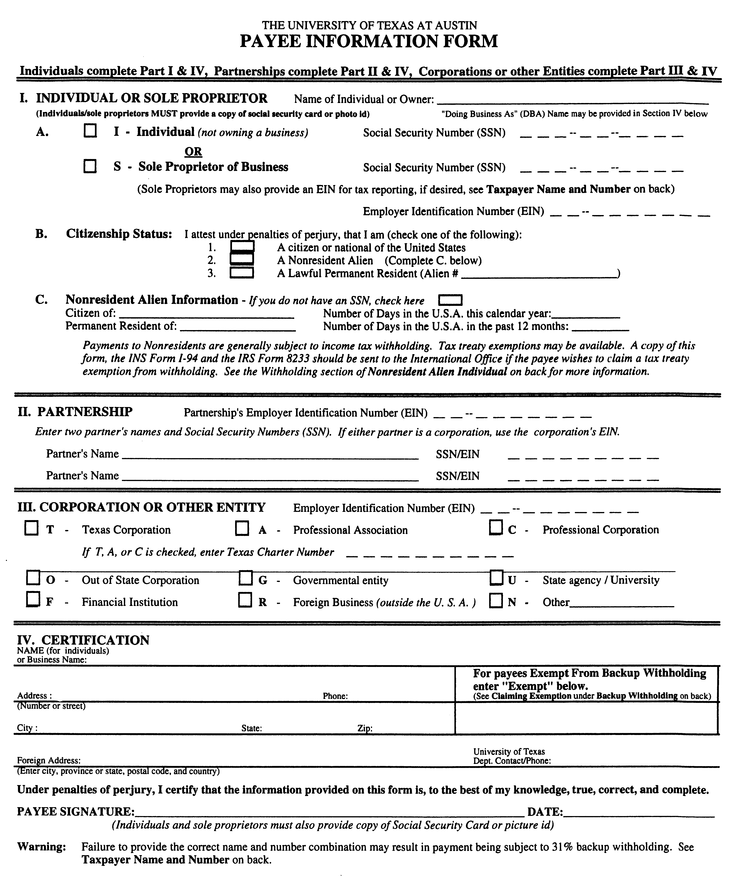

Please affix a clean/clear photocopy
of your picture ID here.
Thank you!

Notice Concerning Your Information

The Texas Public Information Act, with a few exceptions, gives you the right to be informed about the information that The University of Texas at Austin collects about you. It also gives you the right to request a copy of that information; and to have The University correct any of that information that is wrong. You may request to receive and review any of that information, or request corrections to it, by contacting the University's Public Information Officer, Office of Financial Affairs, PO Box 8179, Austin, Texas, 78713 (email:cfo@www.utexas.edu).

