Date | Session # | Session Title | Presenter(s)  Name(s) | Start/End  Time | PD Time  Earned
TOTAL Professional Development Hours Accrued:
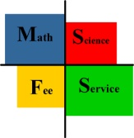
ESC VI M/SFS
Texas Regional Collaborative for
Excellence in Mathematics Teaching
Signature _________________________________
Date _________________________________
I certify that the above information is accurate and complete.
Note: PD time earned should be the time actually spent in sessions and/or workshops.
Conferences provide excellent opportunities for professional development. Quality speakers give numerous presentations. Individual needs are met as participants choose the sessions to attend. The exhibits offer a way to examine available resources. Educators also enjoy the many networking possibilities.
Educator’s Name: _____________________________________________________
Conference ________________________________________
Location ____________________________________
Date _____________________________

