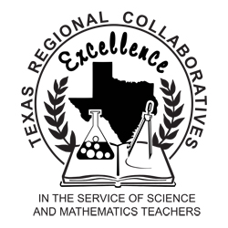

Presented to
Dr. Stephen R. Hensley

In Recognition and Gratitude
For a
Legacy of Leadership,
Support,
&
Commitment to the
East Texas Regional Collaborative
for Excellence in Science Teaching

Honoring the Teachers Celebration
May 15, 2008
Texarkana, Texas

Presented to
The Honorable Stephen Frost

In Great Appreciation
For
Exemplary Public Service
&
Support to
Excellence in Science Education
For All Students

Honoring the Teachers Celebration
May 15, 2008
Texarkana, Texas

Presented to
Frank Coleman

In Recognition and Gratitude
For Your
Support
&
Commitment to the
East Texas Regional Collaborative
for Excellence in Science Teaching

Honoring the Teachers Celebration
May 15, 2008
Texarkana, Texas

