Texas Regional Collaboratives
for Excellence in Science and Mathematics Teaching

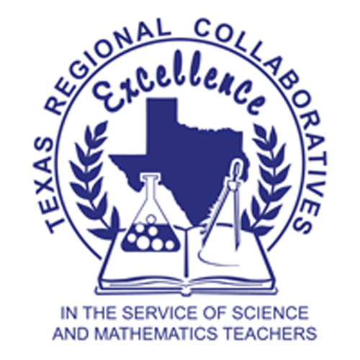

Program Summary
TEA Final Report

2007 – 2008 Grant
February 27, 2009

For additional information regarding the Texas Regional Collaboratives, please contact Kamil A. Jbeily, Executive Director, at kjbeily@mail.utexas.edu or Carol Fletcher, Assistant Director, at carol.fletcher@mail.utexas.edu. View the TRC website at www.theTRC.org

Table of Contents
Texas Regional Collaboratives for Excellence in Science and Mathematics Teaching (TRC) 3
Mission 3
Program Description 3
TRC Network 4
Science Regional Collaboratives 5
Mathematics Regional Collaboratives 6
Teachers and Students Served 9
Project Impact 14
TRC PDA Evaluation Results 16
Texas Mathematics and Science Diagnostics System item review 22
Teacher Impact 23
Teacher Content Knowledge 25
Student Impact 26
Challenges and Successes 32
Conclusion 32
Appendix 34

Texas Regional Collaboratives for Excellence in Science and Mathematics Teaching
Program Summary/TEA Final Report
2006-07 Grant

Texas Regional Collaboratives for Excellence in Science and Mathematics Teaching (TRC)

The TRC is an award-winning statewide network of sixty-one P-16 partnerships that provide sustained and high intensity professional development to P-12 teachers of science and mathematics across the state. This infrastructure of over 48 institutions of higher education collaborating with the Texas Education Agency, education service centers, school districts, and business partners, has a 17-year track record of designing and implementing exemplary professional development using research-based instructional models, materials, and best practices.

Mission

To provide Texas science and mathematics teachers with support systems of scientifically researched, sustained, and high intensity professional development and mentoring to assist them in the implementation of the Texas Essential Knowledge and Skills (TEKS). Our programs equip teachers with the knowledge and skills to engage students in meaningful science and mathematics learning experiences. Activities are designed to improve students’ scientific, mathematical and technological literacy, and inspire them to pursue science and engineering related careers.

Program Description

The TRC has three basic components of professional development. First, Instructional Team Members, or ITMs, from each Regional Collaborative are assembled to provide training to classroom teachers. Instructional Teams ideally consist of professors of Mathematics, Mathematics Education, Mathematics Specialists, Science, Science Education, Science Specialists and Master Teachers in each region. Professional Development Academies (PDAs) are provided by the TRC to ITMs from across the state to focus instruction on the priorities set by the Texas Regional Collaboratives and the Texas Education Agency and to improve the quality and effectiveness of professional development provided to teachers. PDAs enhance the knowledge and skills necessary to develop, sustain, and facilitate high quality Professional Development Programs in each region.

Second, each Regional Collaborative develops a Professional Development Program (PDP) that addresses both the TRC and TEA priorities for the year and the unique needs of teachers in their region. The PDP is provided to a network of Science Teacher Mentors (STMs) or Mathematics Teacher Mentors (MTMs) from multiple districts in each region. A minimum of 25 STMs and MTMs from each Regional Collaborative is required, but several Collaboratives serve more than double that number. The PDP consists of training to improve teacher science content knowledge, instructional skills, classroom practice, and leadership capacity. In 2007-08, STMs received an average of 105 contact hours of professional development in these areas. The Mathematics Collaboratives have been tasked with building a sustained network in their first 2 years. Therefore, in 2007-2008 they did not target a specific number of professional development contact hours. Through their participation in the TRC, STMs and MTMs also receive the instructional materials necessary to implement the hands-on inquiry based lessons that they have been trained on in their classrooms.

Through their experiences with the Regional Collaboratives, STMs and MTMs become true leaders in science and mathematics education in their schools and districts. To maximize the investment made in these individuals, STMs are required to mentor additional teachers, termed Cadre Members (CMs), throughout the year, and serve as resources for improving student experiences in science both regionally and statewide. In 2008-09 MTMs will be required to do the same. Using this multiplier effect, the TRC is able to scale up the number of teachers served across the state at a relatively low cost. Some mentoring occurs informally through the sharing of ideas and expertise on a campus level, team teaching, and coaching. In addition, many STMs provide formal training and outreach through workshops on science topics such as Bridging II TAKS, 5E lesson planning and implementation, aligning instruction and assessment to the TEKS and TAKS, and other more specific locally based training. This mentoring model gives STMs an opportunity to grow professionally as leaders while remaining classroom teachers. Such professional growth is not often encouraged within the confines of the traditional limitations of school culture.

This fact makes participation in the TRC especially valuable to experienced teachers who wish to improve their knowledge, skills, and leadership without leaving the classroom. Cadre Members receive an average of 12 documented hours of mentoring, training, and support. Many individual teachers that participated as CMs during the 2006-07 project year chose to increase their level of commitment and become STMs for the 2007-08 program. Each of these components contributes to the overall goal of improving the quality and rigor of classroom science instruction for P-12 students.

TRC Network

During the 2007-08 grant period, the TRC issued subawards to support 37 Regional Science Collaboratives and 22 Regional Mathematics Collaboratives across the state. Each Regional Collaborative consisted of a partnership among numerous organizations and stakeholders with a vested interest in quality science instruction including institutes of higher education, school districts, charter schools, private schools, Education Service Centers (ESCs), and business and industry. Science and Mathematics Regional Collaboratives grantees are listed in the next section by fiscal agent.

Science Regional Collaboratives

Each year, the TRC offers Professional Development Academies (PDAs) in science content areas and grade levels consistent with state priorities and student achievement data. For the grant year 2007-2008, each Science Regional Collaborative provided professional development in Earth Science for Grades K-8 and/or Physics for Grades 8-12. Programs that meet local needs provided the balance of hours towards the 105 contact hour program duration.

Science Regional Collaboratives
- Region 1 Collaborative / Edinburg
- UT-Brownsville Regional Collaborative / Brownsville
- UT-Pan American Regional Collaborative / Edinburg
- TAMIU Regional Collaborative / Laredo
- TAMU-Corpus Christi / ESC 2 Regional Collaborative / Corpus Christi
- Region 3 Collaborative / Victoria
- Region 4 Collaborative / Houston
- Lake Houston Regional Collaborative / Humble
- Rice University Regional Collaborative / Houston
- UH-Clear Lake / EIH Regional Collaborative / Houston
- Aldine ISD Regional Collaborative / Houston
- Galveston County Regional Collaborative / Galveston
- Region 5 Collaborative / Beaumont
- TAMU-College Station Regional Collaborative /College Station
- Region 7 Collaborative / Kilgore
- Region 8 Collaborative / Mount Pleasant
- TAMU-Texarkana Regional Collaborative / Texarkana
- Region 9 Collaborative / Wichita Falls
- Region 10 Collaborative / Richardson
- UT-Dallas Regional Collaborative / Dallas
- University of Dallas Regional Collaborative / Irving
- Region 11 Collaborative / Fort Worth
- University of North Texas Regional Collaborative / Denton
- North Central Texas College Regional Collaborative / Gainesville
- Region 12 Collaborative / Waco
- Region 13 Collaborative / Austin
- Capital City Regional Collaborative / Austin
- ACC Regional Collaborative / Austin
- Region 14 Collaborative / Abilene
- Region 15 Collaborative / San Angelo
- Region 16 Collaborative / Amarillo
- Region 17 Collaborative / Lubbock
- Region 18 Collaborative / Midland
- Region 19 Collaborative / El Paso
- Region 20 Collaborative / San Antonio
- OLLU Regional Collaborative / San Antonio
- UT-Tyler Regional Collaborative Tyler

Mathematics Regional Collaboratives

In July 2006, the TRC launched a new initiative funded by the Texas Education Agency (TEA) to provide high quality professional development for Texas mathematics teachers. After a competitive process, grants were awarded to 20 partnerships across the state. For the grant year 2007-08, 22 Mathematics Regional Collaboratives continued to provide professional development utilizing the mathematics modules developed by TEA in collaboration with universities across the state. These include Math TEKS Connections-Preservice, Teaching Math TEKS Through Technology (TMT3), Math TEKS Refinements (MTR), Math TEKS Connections (MTC), Math for English Language Learners (MELL), Algebra II, and MTC Geometry. Additionally, math teachers received training in the Texas Math and Science Diagnostic System, and various locally sponsored trainings that support teachers' use of math and literature. Many Collaboratives supported teachers’ attendance to the 2008 Conference for Advancement in Mathematics Teaching (CAMT). Collaboratives deliver a minimum of 3000 contact hours each to teachers in their respective regions.

Mathematics Regional Collaboratives
- Region 1 Collaborative/Edinburg
- Region 2 Collaborative/Corpus Christi
- Region 3 Collaborative/Victoria
- Region 4 Collaborative/Houston
- Region 5 Collaborative/Beaumont
- Region 6 Collaborative/Huntsville
- Region 7 Collaborative/Kilgore
- UT-Tyler Regional Collaborative/Tyler
- Region 8 Collaborative/Mount Pleasant
- Region 9 Collaborative/Wichita Falls
- Region 10 Collaborative/Richardson
- Region 11 Collaborative/Ft. Worth
- Region 12 Collaborative/Waco
- Region 13 Collaborative/Austin
- Region 14 Collaborative/Abilene
- Region 15 Collaborative/San Angelo
- Region 16 Collaborative/Amarillo
- Region 17 Collaborative/Lubbock
- Region 18 Collaborative/Midland
- Region 19 Collaborative/El Paso
- Region 20 Collaborative/ San Antonio
- OLLU Regional Collaborative/San Antonio

During the 2007-08 grant period, 46 Institutions of Higher Education partnered with Regional Collaboratives across the state to provide high quality science and mathematics professional development. While many of these were fiscal agents as noted above, still others partnered with ESCs to provide coursework and training to teachers.

- Abilene Christian University
- Amarillo College
- Angelo State University
- Austin Community College
- Baylor University
- Concordia University Texas
- Hardin-Simmons University
- Kansas University
- Lamar University
- Lee College
- Lone Star College - Kingwood
- Midland College
- Midwestern State University
- North Central Texas College
- Our Lady of the Lake University
- Rice University
- Stephen F. Austin State University
- Texarkana College
- Texas A&M University
  - TAMU International
  - TAMU -Agricultural Research and Extension Center at Beaumont
  - TAMU - College Station
  - TAMU - Commerce
  - TAMU - Corpus Christi
  - TAMU - Galveston
  - TAMU - Texarkana
- Texas Christian University
- Texas Southern University
- Texas State University
- Texas Tech University
- University of Houston-Clear Lake
- UH-Clear Lake/Environmental Institute of Houston
- University of Northern Iowa
- University of Dallas
- University of North Texas
- The University of Texas System
  - University of Texas at Arlington
  - University of Texas at Austin
  - University of Texas at Austin, Bureau of Economic Geology
  - University of Texas at Austin, McDonald Observatory
  - University of Texas at Brownsville
  - University of Texas at Dallas
  - University of Texas at El Paso
  - University of Texas - Pan American
  - University of Texas at Tyler
  - University of Texas Medical Branch
- Victoria College
- West Texas A&M University

Instructional Team Members for the Collaboratives from these colleges and universities provided training to P-12 teachers and served as content experts. In addition to faculty members in higher education, other ITMs included informal science providers such as museum staff members, education service center science and mathematics specialists, and K-12 science and mathematics administrators. The greatest number of ITMs were Instructional Specialists (33%) followed by master teachers (19%) and science professors (18%). Math professors composed 8% of the ITM pool. Education professors, typically from a college of education, comprised 7% of ITMs with the rest distributed among K-12/IHE administrators, informal science educators, and professors of engineering.

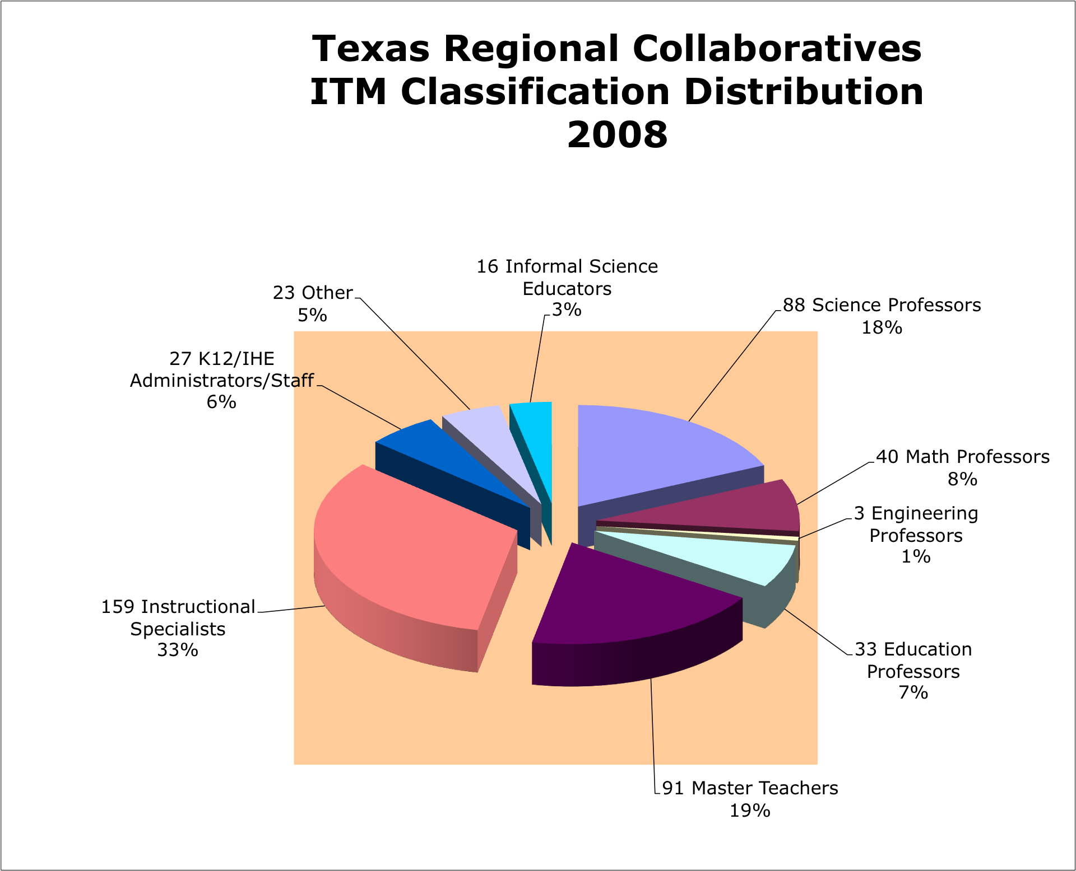
Figure 1: Distribution of ITMs 2007-2008

Teachers and Students Served
In addition to these higher education and ESC partners, teachers from 812 school districts and charter schools and 2,342 campuses participated in the Texas Regional Collaboratives science program. The Mathematics Regional Collaboratives served teachers in 819 districts and charter schools representing 2,158 campuses. A list of all participating districts is located in the Appendix.
During the 2007-08 project year, a total of 7,958 science educators and 8,053 mathematics educators were served by the Texas Regional Collaboratives. Information on educators and students served was generally collected by having each educator complete a TRC Participant Data Form (see Appendix). In some cases, participants who attended workshops did not complete an entire form, but only provided information such as their name, campus, district, and grades or subjects taught. Based on an average student/teacher ratio of 65.4 students per TRC teacher, approximately 517,270 students have been impacted by TRC professional development. Mathematics teachers averaged 58.1 students per teacher for a total impact of 467,074 students. A breakdown of teacher demographics is described in Tables 1-7 while school and student demographics are described in Tables 8-11.

Table 1. Teacher Gender
 | Science |  | Math
 | Number | Percent | Number | Percent
Male | 1,031 | 15% | 1,111 | 15%
Female | 5,987 | 85% | 6,234 | 85%

Table 2. Teacher Ethnicity
 | Science |  | Math
 | Number | Percent | Number | Percent
African American | 374 | 6% | 462 | 7%
Asian American | 83 | 1% | 91 | 1%
Caucasian | 4,421 | 68% | 4,407 | 64%
Hispanic | 1,501 | 23% | 1,804 | 27%
Native American | 29 | 1% | 22 | 1%
Other | 115 | 2% | 111 | 1%

Figure 2. TRC Science Teacher Ethnicity Figure 3. TRC Math Teacher Ethnicity

Table 3. Teaching Level and Job Title
 | Science |  | Math
 | Number | Percent | Number | Percent
Elementary | 4,431 | 69% | 4,671 | 53%
Middle School | 1,092 | 17% | 1,572 | 18%
High School | 853 | 13% | 1,653 | 19%
Univ/College | 22 | <1% | 12 | <1%
Admin | 65 | 1% | 192 | 2%
Classroom Teacher | 6,081 | 88% | 6,089 | 88%
Specialist/Facilitator | 174 | 2% | 221 | 3%
Education Student | 285 | 4% | 163 | 2%
Paraprofessional | 65 | 1% | 41 | 1%
Informal Education | 10 | <1% | 1 | <1%
Non-Teaching Science Coach | 24 | <1% | 4 | <1%
Non-Teaching Math Coach | 1 | <1% | 39 | 1%
ESC | 14 | <1% | 12 | <1%
Consultant | 4 | <1% | 12 | <1%
Administrator | 148 | 2% | 136 | 2%
Other | 110 | 2% | 172 | 2%

Figure 4. TRC Science Teacher Level Figure 5. TRC Math Teacher Level
Table 4. Highly Qualified
 | Science |  | Math
 | Number | Percent | Number | Percent
Yes | 3,607 | 76% | 4,164 | 78%
No | 127 | 3% | 177 | 3%
Not Sure | 1,025 | 22% | 979 | 18%

Table 5. Grades Currently Taught
Science
 | Number | Percent |  |  | Number | Percent
PreK | 141 | 2% |  | 6th | 463 | 6%
K | 463 | 6% |  | 7th | 437 | 5%
1st | 552 | 7% |  | 8th | 463 | 6%
2nd | 626 | 8% |  | 9th | 462 | 6%
3rd | 865 | 11% |  | 10th | 520 | 7%
4th | 897 | 11% |  | 11th | 507 | 6%
5th | 1,113 | 14% |  | 12th | 463 | 6%

Math
 | Number | Percent |  |  | Number | Percent
PreK | 115 | 1% |  | 6th | 619 | 6%
K | 539 | 5% |  | 7th | 696 | 7%
1st | 621 | 6% |  | 8th | 741 | 7%
2nd | 661 | 6% |  | 9th | 1,042 | 10%
3rd | 754 | 7% |  | 10th | 1,164 | 11%
4th | 685 | 7% |  | 11th | 1,085 | 11%
5th | 574 | 6% |  | 12th | 900 | 9%

Table 6. Subject Currently Taught
Science
 | Number | Percent
Elementary Science | 3,354 | 62%
Middle School Science | 805 | 15%
IPC | 295 | 5%
Biology | 240 | 4%
Chemistry | 215 | 4%
Physics | 188 | 3%
AP Science | 76 | 1%
Other Science | 218 | 4%

Table 7. Subject Currently Taught

Math
 | Number | Percent
Elementary Math | 2,962 | 42%
Middle School Math | 1,248 | 18%
AP/IB Math | 63 | 1%
Algebra 1 | 870 | 12%
Algebra 2 | 550 | 8%
Geometry | 661 | 9%
Calculus | 95 | 1%
Math Models | 224 | 3%
Other Math | 372 | 5%
Table 8. Campus Type
 | Science |  | Math
 | Number | Percent | Number | Percent
Public | 2,035 | 94% | 1899 | 92%
Private | 77 | 4% | 40 | 2%
Alternative | 34 | 2% | 97 | 5%
Charter | 10 | <1% | 19 | 1%
Other | 10 | <1% | 19 | 1%

Table 9. Poverty Level
 | Science |  | Math
 | Number of schools | Percent | Number of schools | Percent
Low (<35%) | 328 | 17% | 282 | 17%
Medium (35%-50%) | 364 | 19% | 400 | 24%
High (51%-75%) | 576 | 31% | 528 | 31%
Very High (>75%) | 610 | 32% | 480 | 28%

Figure 6. TRC Science Free Lunch Figure 7. TRC Math Free Lunch

Table 10. Title I Status
 | Science |  | Math
 | Number | Percent | Number | Percent
YES | 821 | 80% | 1,000 | 79%
NO | 206 | 20% | 265 | 21%

Table 11. Student Ethnicity
 | Science |  | Math
 | Number | Percent | Number | Percent
African American | 35,929 | 13% | 34,335 | 13%
Asian American | 6,794 | 2% | 4,275 | 2%
Caucasian | 102,906 | 38% | 100,682 | 37%
Hispanic | 124,469 | 46% | 129,480 | 48%
Native American | 948 | 0% | 800 | 0%
Other | 1,476 | 1% | 1,689 | 1%

Figure 8. TRC Science Student Ethnicity Figure 9. TRC Math Student Ethnicity

Project Impact

The total number of Science Teacher Mentors (STMs) served in 2007-08 was 1,407. Each STM received an average of 100 contact hours of professional development. The total number of Cadre Members (CMs) served was 6,063 with each CM receiving an average of 15 contact hours. The total number of Mathematics Teacher Mentors served in 2007-08 was 8,053. Please note the Mathematics Collaborative did not have CMs during 07-08. All participants were considered MTMs.

The total number of contact hours provided by the TRC was 265,939 (Science 203,418 and Math 62,521). This included college credit hours that many teachers earned through taking coursework at the Institutions of Higher Education listed previously. Such college courses primarily focus on improving teachers’ science content knowledge and are taught by science and science education professors from across the state. Many teachers are able to use their involvement in the TRC to earn a master’s degree from institutions that work in close collaboration with the Regional Collaboratives such as Texas Tech, UT-Brownsville, UT-Pan American, Texas A&M-Texarkana, and Our Lady of the Lake University.

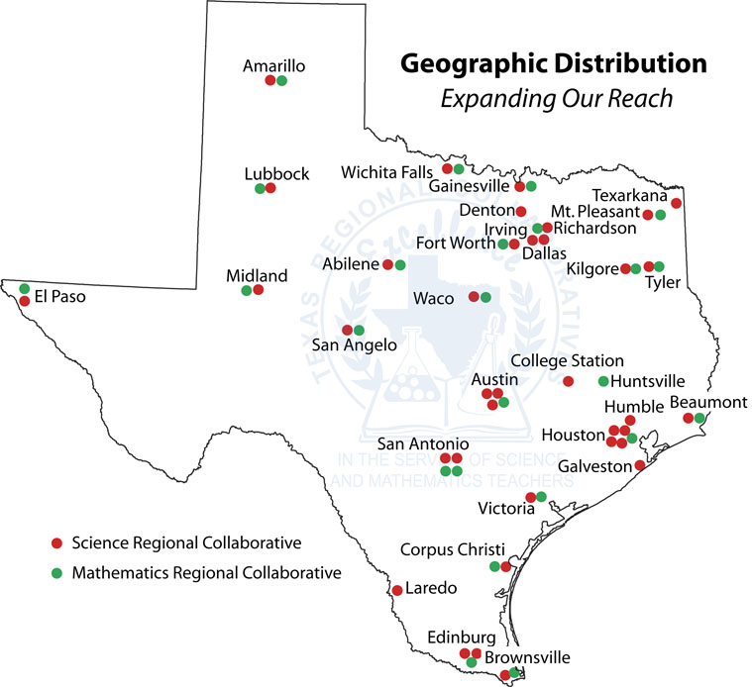
Figure 10. TRC Geographic Distribution

The TRC also hosted science and math professional development workshops during 2007-2008 as described in Table 12. In summary, the TRC provided 244 hours of science professional development to 254 participants and 72 hours of mathematics professional development to 167 participants.

Table 12. TRC Science Professional Development

DATE (2008) | TITLE | HOURS | PARTICIPANTS
February 7-8 | Bridging II TAKS in Spanish | 20 | 22
February 14-16 | TXESS PDA 1 | 24 | 58
April 3-5 | TXESS PDA 2 | 24 | 64
May 13-15 | Texas Connection | 36 | 18
June 15-27 | TXESS Summer Institute | 80 | 21
June 16-20 | Chemistry for All | 40 | 24
June 11-13 | Middle School Chemistry | 20 | 47
 | TOTAL | 244 | 254

Table 13. TRC Math Professional Development
DATE | TITLE | HOURS | PARTICIPANTS
April 24-25 | Teacher Knowledge Assessment | 12 | 53
May 19-22 | Children’s Thinking in Measurement | 18 | 42
June 2-4 | Fostering Algebraic Thinking | 24 | 50
June 24-26 | MTC Geometry | 18 | 22
 | TOTAL | 72 | 167

TRC PDA Evaluation Results

The TRC professional development evaluation results include measures of quality, impact, effectiveness, utility, active learning, and organization. An aggregate measure for science and math PDAs is presented next in a series of figures.
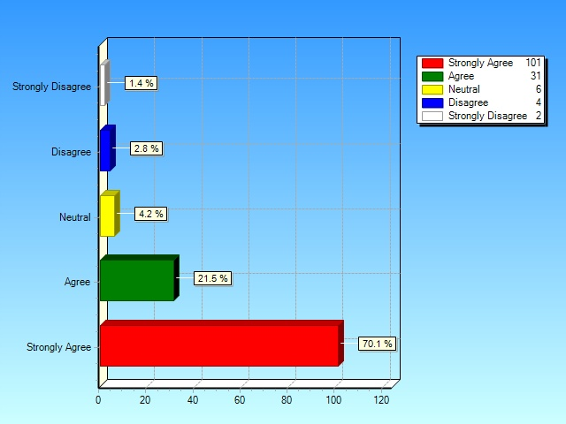
Figure 11. The PDA was of high quality

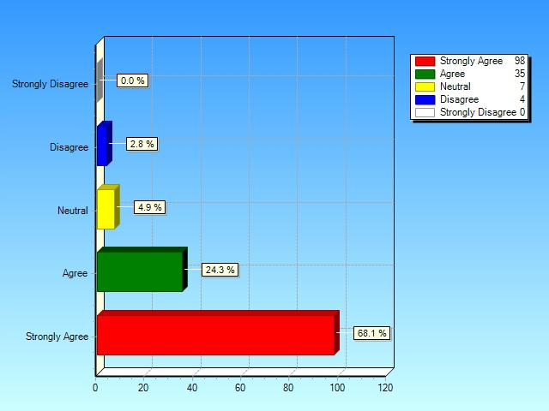
Figure 12. The PDA content will be very useful to me and will be
useful to the STMs/MTMs.

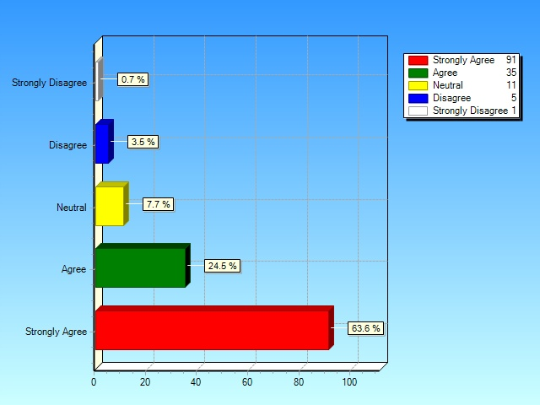
Figure 13. Overall, the presenter was effective.

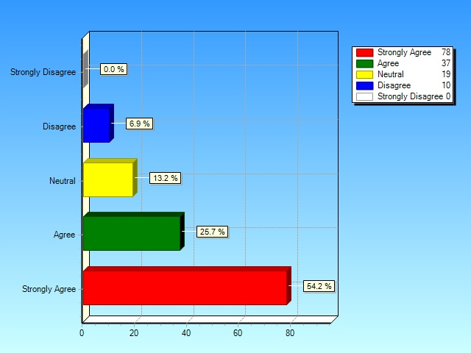
Figure 14. The PDA was well organized.

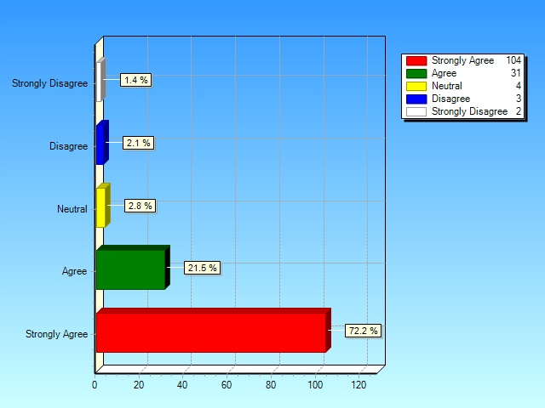
Figure 15. The content and activities of the PDA were useful.

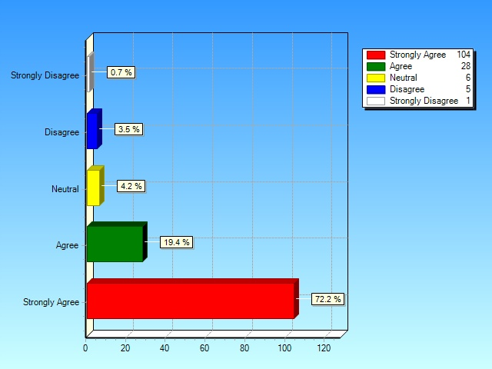
Figure 16. The content and activities of the PDA provided opportunities for active learning.

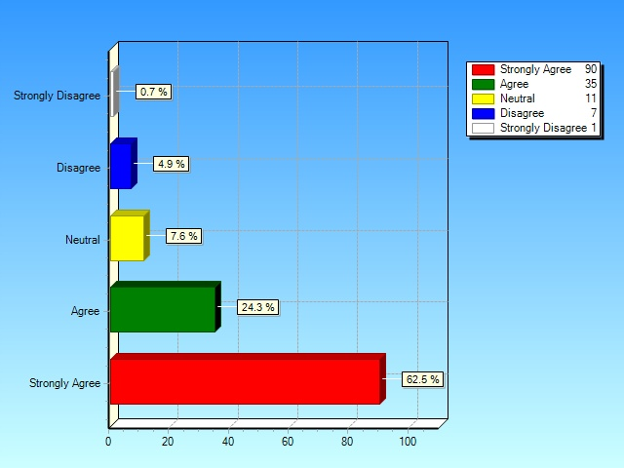
Figure 17. The presenter used effective instructional models.
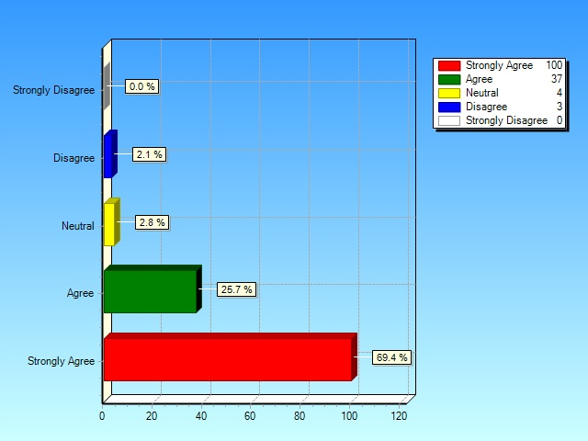
Figure 18. The materials presented in the PDA are useful.

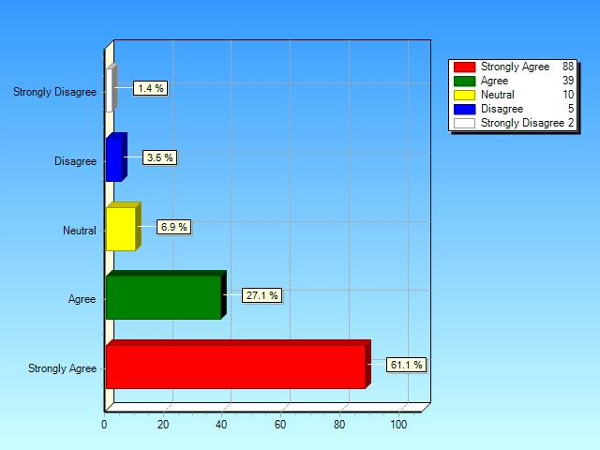
Figure 19. The purpose of this training was well defined.

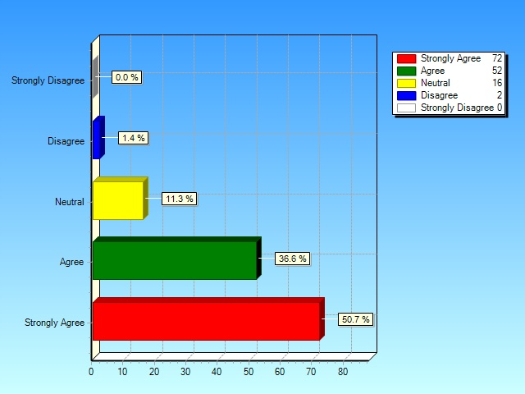
Figure 20. The participants of this meeting have a clear understanding of the agreement and responsibilities.

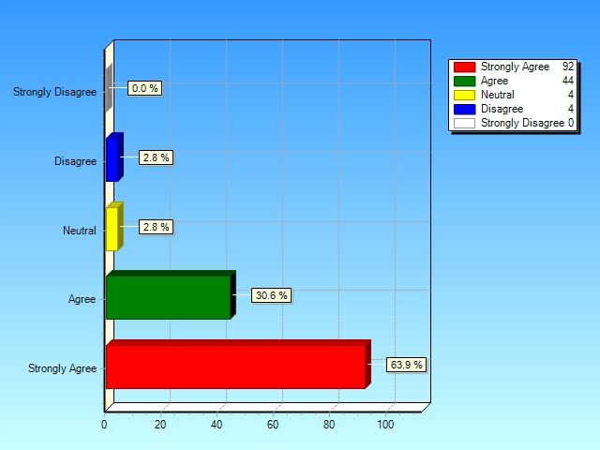
Figure 21. The topics addressed at this meeting are relevant and important to the services I provide.
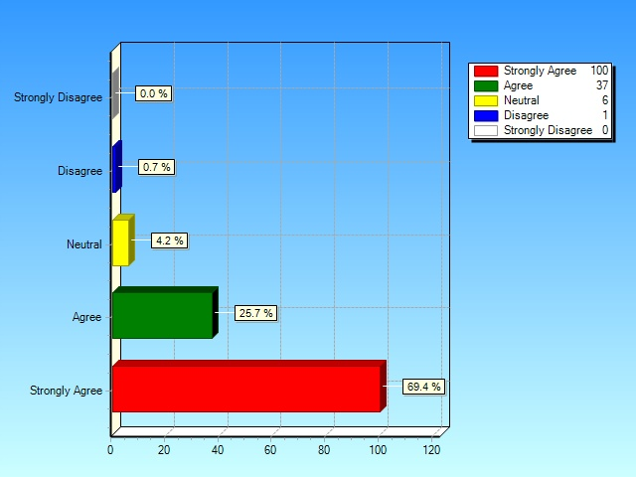
Figure 22. Meeting and/or talking with participants was a valuable experience.

Texas Mathematics and Science Diagnostics System item review

The Texas Education Agency also requested that the TRC conduct an item review for the Texas Mathematics and Science Diagnostics System. The TRC teachers reviewed 5,000+ science and mathematics items. Two types of reviews were held: (1) content and alignment for science 3-12 and mathematics high school only and (2) math alignment only for Grades 3-8.

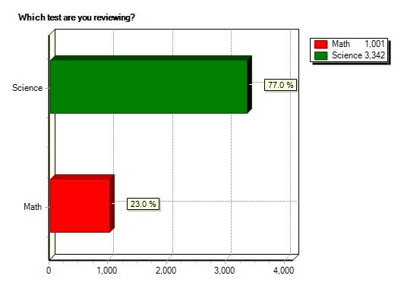
Figure 23. Science and Math Content and Alignment Review.
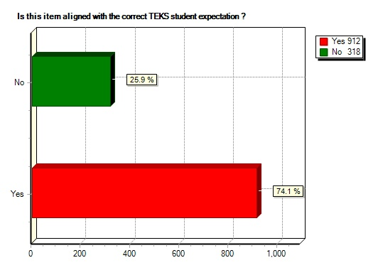
Figure 24. Math Alignment Only

Teacher Impact

The TRC program evaluation focuses on 3 major components:
- Impact on teacher practice and instructional skills
- Impact on teacher content knowledge
- Impact on student achievement

TRC educators were asked in the 14th Annual Meeting evaluation, “How has the TRC made a difference for you as a professional educator? Statements from the teachers follow.

- My knowledge of science has improved as has my teaching methods. My students have been successful because of it. This year I had 100% pass the TAKS Science 5th grade with 70% commended within a population majority Hispanic and disadvantaged. These students would not have been as successful without my participation in the TRC.
- After one year of attending the TRC I gained the confidence and knowledge I needed to be successful in the classroom. This was evident from the dramatic increase in TAKS scores from 69% to 91%. I directly attribute this increase to what I learned in the TRC.
- TRC has supported my efforts to become informed on ways to bring active, hands-on science learning into my ESL classroom in cross-curriculum, TEKS aligned lessons.
- The TRC has opened up doors for me to move up professionally. I have gone from a classroom teacher to the Science Curriculum Coordinator for a school district. I have also been able to help teachers improve their instruction and strategies in the classroom, making an impact on student achievement. Because of the TRC I am constantly learning the most current up to date information and strategies in science education.
- The TRC has made a HUGE difference to me! Almost everything that I have taught in the last four years has somehow been connected to the training I have received from the TRC.
- I feel more equipped to make a difference in my classroom and school. Because of the TRC, I've been given the confidence to teach high school science after 20 years of teaching Jr. High. I also feel more qualified to help other science teachers.
- Truly I got my start as a professional educator in the OLLU collaborative about 12 years ago and now I am a Project Director. OLLU helped build my confidence, expand my horizons, and provided me with opportunities that have helped me attain the position I have today. The best part is I now get to pass on that legacy to others and watch them grow.
- I came away with a better understanding of the passion and commitment of the TRC leadership than I arrived with. I felt, as a teacher, appreciated for the first time in a long time. I am excited about teaching and using the content, the activities, and the materials I have received from the collaborative. It has given me a new outlook and I have hope of making a bigger difference on my campus and in my students' lives. This was a wonderful experience and one that I look forward to sharing with my colleagues and hopefully repeating next summer. Thank you for the opportunity.
- I am more willing to try new and exciting things, more willing to fail and evaluate that failure, more willing to mentor others and promote ideas.
- TRC has taught me not only about science but how to teach science to my students. I am more comfortable so my students have a great time in school. If you ask them what their favorite subject is, they'll tell you it's science.... because we do "cool stuff"!
- How has the TRC NOT made a difference? It has allowed me to grow as a teacher in the classroom and as a leader in my district. It has provided me with activities and lessons that helped my students achieve success on more than just the TAKS test. It has provided me with opportunities to collaborate with like-minded teachers who love their students and love their jobs. An English teacher once called me "Pollyanna Perkypants", and I don't think she meant it in a complimentary way, but when I am with other TRC teachers ... I feel like I am home ... I'm with a whole bunch of other teachers who have a positive perspective about what great things we can help our students achieve.
- After being in administration for so long and then returning to a science role, it has really stretched my knowledge base about teaching science.
- Networking / collaborating with other teachers across the state - sharing my "pain" with peers across the state and learning from them how they cope with problems and how they overcome teaching difficulties (either the TAKS test or individual concepts in science like density for instance...). The professional development I have received and have shared with the members or my collaborative have made me a much better teacher. I understand much more about how people learn (whether the person is a child or an adult), how they are motivated and how the 5E model (when used appropriately) is invaluable to the education of a student. People have to learn how to solve problems on their own in order to truly gain knowledge (the "explore" part of the 5E). This inquiry is essential in order to create problem solvers. I also like finding out through the TRC about different learning opportunities for teachers across the state.
- TRC has greatly impacted my teaching career. Since I am a younger teacher, being able to talk with, and get ideas from everyone has been life changing. I work at a 1A school where I am the science dept. at our school, so collaboration is imperative for success in the classroom.
- The TRC has opened many, many doors for science teachers in our area. Each year there are more opportunities to improve the content knowledge and strategies of the science teachers. It is important for these STMs to be able to share and network with other teachers from around the state of Texas! So, the TRC has made a great difference to me personally and the teachers I work with in our collaborative.
- How can I even begin? I have been in a collaborative almost consecutively for over 10 years. The year or two that I did not belong to one I felt like I was really missing out on the communication that develops between fellow teachers. The TRC has allowed me to participate in events that I would not have known about and see speakers that I would never have seen in my area of the state. It has broadened my horizons and thus changed the opportunities that my students are afforded. You have "grown" me as a teacher and this allows me to be a better "gardener" for my students.
- I have gained tremendous passion for science, as well as many hours of training that have all been passed on to my students and other teachers in my building, district and state. (After TRC annual meeting we headed for Colorado and went fossil hunting and bird watching for 10 days because of passions ignited by TRC workshops. We met a lead teacher from Lake Travis ISD in Durango and inspired her to stop in Taylor County, TX on her way home to dig fern leaf imprints.)

Teacher Content Knowledge

One of the primary goals of the Texas Regional Collaboratives is to improve the science content knowledge of participating teachers. Each Regional Collaborative develops a Professional Development Program to address the unique needs of the teachers who participate in that region. Regional Collaboratives may have a slightly different focus each year depending on the specific grade level of teachers that participate and a regional needs assessment. Needs assessments generally include an examination of student TAKS scores as well as local data such as district benchmarks to identify areas in need of instructional improvement.

Many of the Regional Collaboratives developed formal procedures for identifying changes in teacher science content knowledge as a result of TRC training. These Collaboratives administered 63 different tests in a pre-test/post-test format. Test content covered a range of topics including physics, chemistry, biology, earth science, and science process skills. The impact of TRC professional development on the content knowledge of teachers is summarized in Figure 25. Pre-test mean scores and post-test mean scores were averaged for all exams resulting in a mean scores of 53% for all pre-tests as compared to a mean score of 67% for all post-tests.

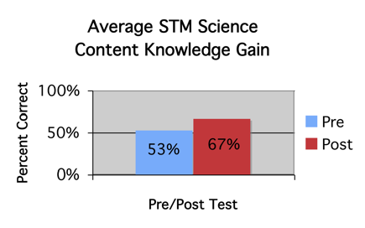
Figure 25: Improvements in STM Science Content Knowledge
There is appreciable and significant 14-point gain in the teacher content knowledge.

Student Impact

One of the most difficult tasks for professional development evaluators is to determine the effect teacher professional development has on student achievement. This is particularly challenging for a large statewide organization that serves teachers in over 500 independent school districts, charter schools, and private schools. With the implementation of the Elementary Science Texas Assessment of Knowledge and Skills (TAKS) test however, evaluators at least have a common metric by which to measure statewide student performance. This test, which is administered at Grade 5, measures student understanding of the TEKS for Grades 2-5. Test data is available only on a campus, district, regional, and state level. Test scores for individual students or students clustered within individual teachers are not available to researchers on a statewide basis. The Science TAKS is also administered at Grades 8, 10, and 11. Since student data cannot be accurately combined across Regional Collaboratives, selected examples are included in this report. In general, analysis of campus TAKS scores where TRC teachers were employed compared to campuses where no TRC teachers were employed indicated that students on TRC campuses outperformed students on non-TRC campuses. When no comparison campuses were provided, Regional Collaboratives examined year-to-year changes from TAKS 2007 to TAKS 2008 to determine impact.

For example, after Hutto ISD teachers joined the TRC in the 2007-08 school year, students significantly increased the percent passing and percent commended in Grade 5 on the Elementary TAKS at the 3 campuses that had TRC teachers.

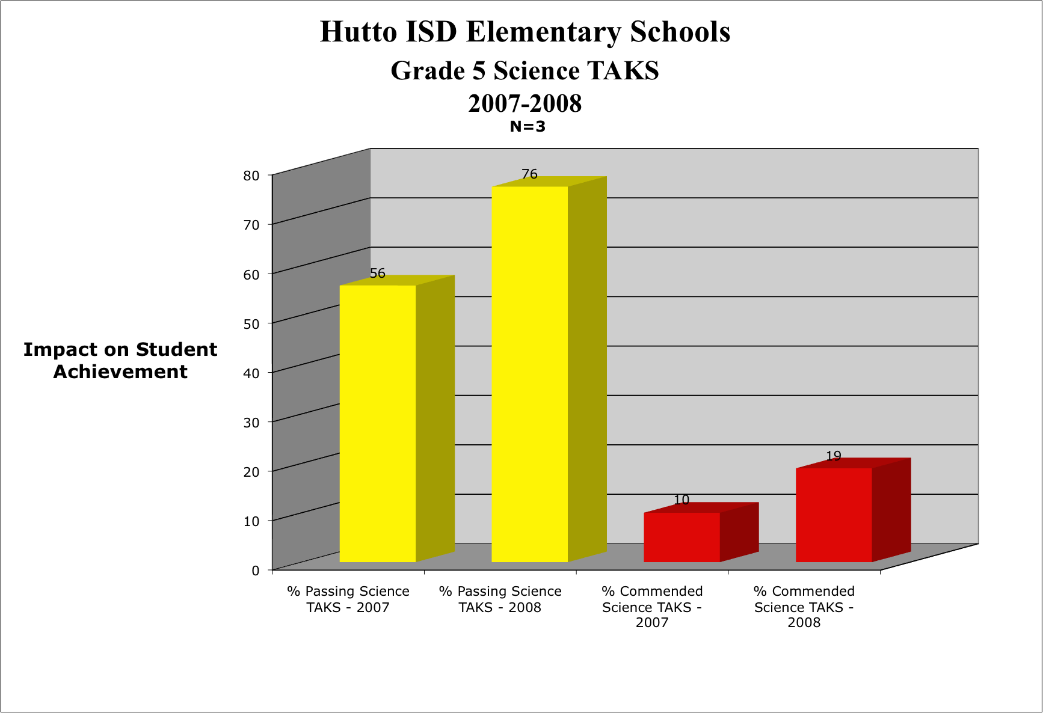
Figure 26. Hutto ISD Grade 5 TAKS
In Region 5, a comparison of TRC campuses on 2006-2007 to 2007-2008 at Grades 5, 8, 10 and 11 demonstrates appreciable gains in passing rates at Grades 5, 10, and 11. The most appreciable gain (19 percentage points) occurred in Grade 10. Followed by 10 percentage points increase in Grade 11. There was a 6-percentage points increase in Grade 5.

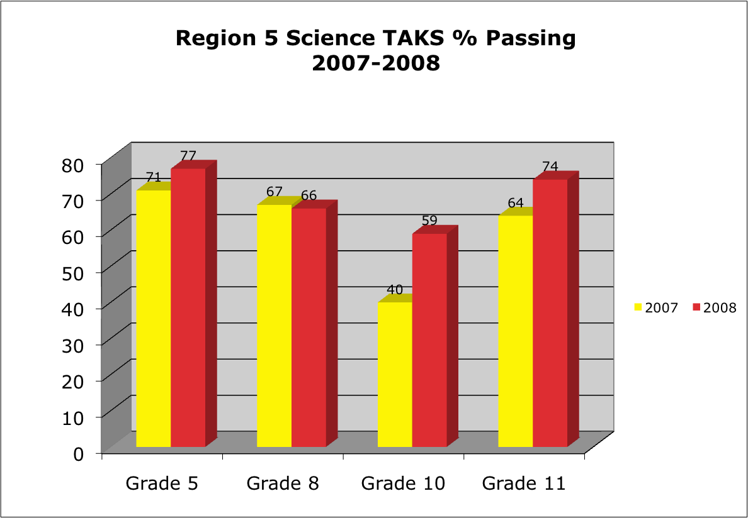
Figure 27. Region 5 Science TAKS

The Region 7 Collaborative provided evidence of student achievement by presenting TAKS data across Region 7 schools as compared to state data and non-collaborative schools. The data strongly indicates teacher/campus TRC membership influences student achievement. Students on Region 7 TRC campuses outperformed students on non-TRC campuses by 11 to 13 percentage points across Grades 5,8, and 11.

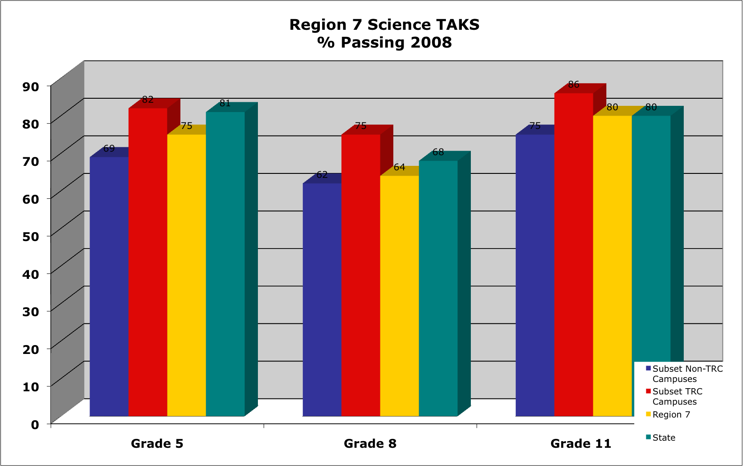

Figure 28. Region 7 Science TAKS

The Region 9 Collaborative performed a comparison of 2006-07 Science TAKS scores to 2007-2008 Science TAKS testing for Grades 5, 8, 10 and 11. There is appreciable increase in the 2007-2008 Science TAKS scores. The most appreciable gain (14 percentage points) occurred in Grade 11. Followed by 6 percentage points increase in Grade 8 and Grade 10. There was a 5-percentage point increase in Grade 5.

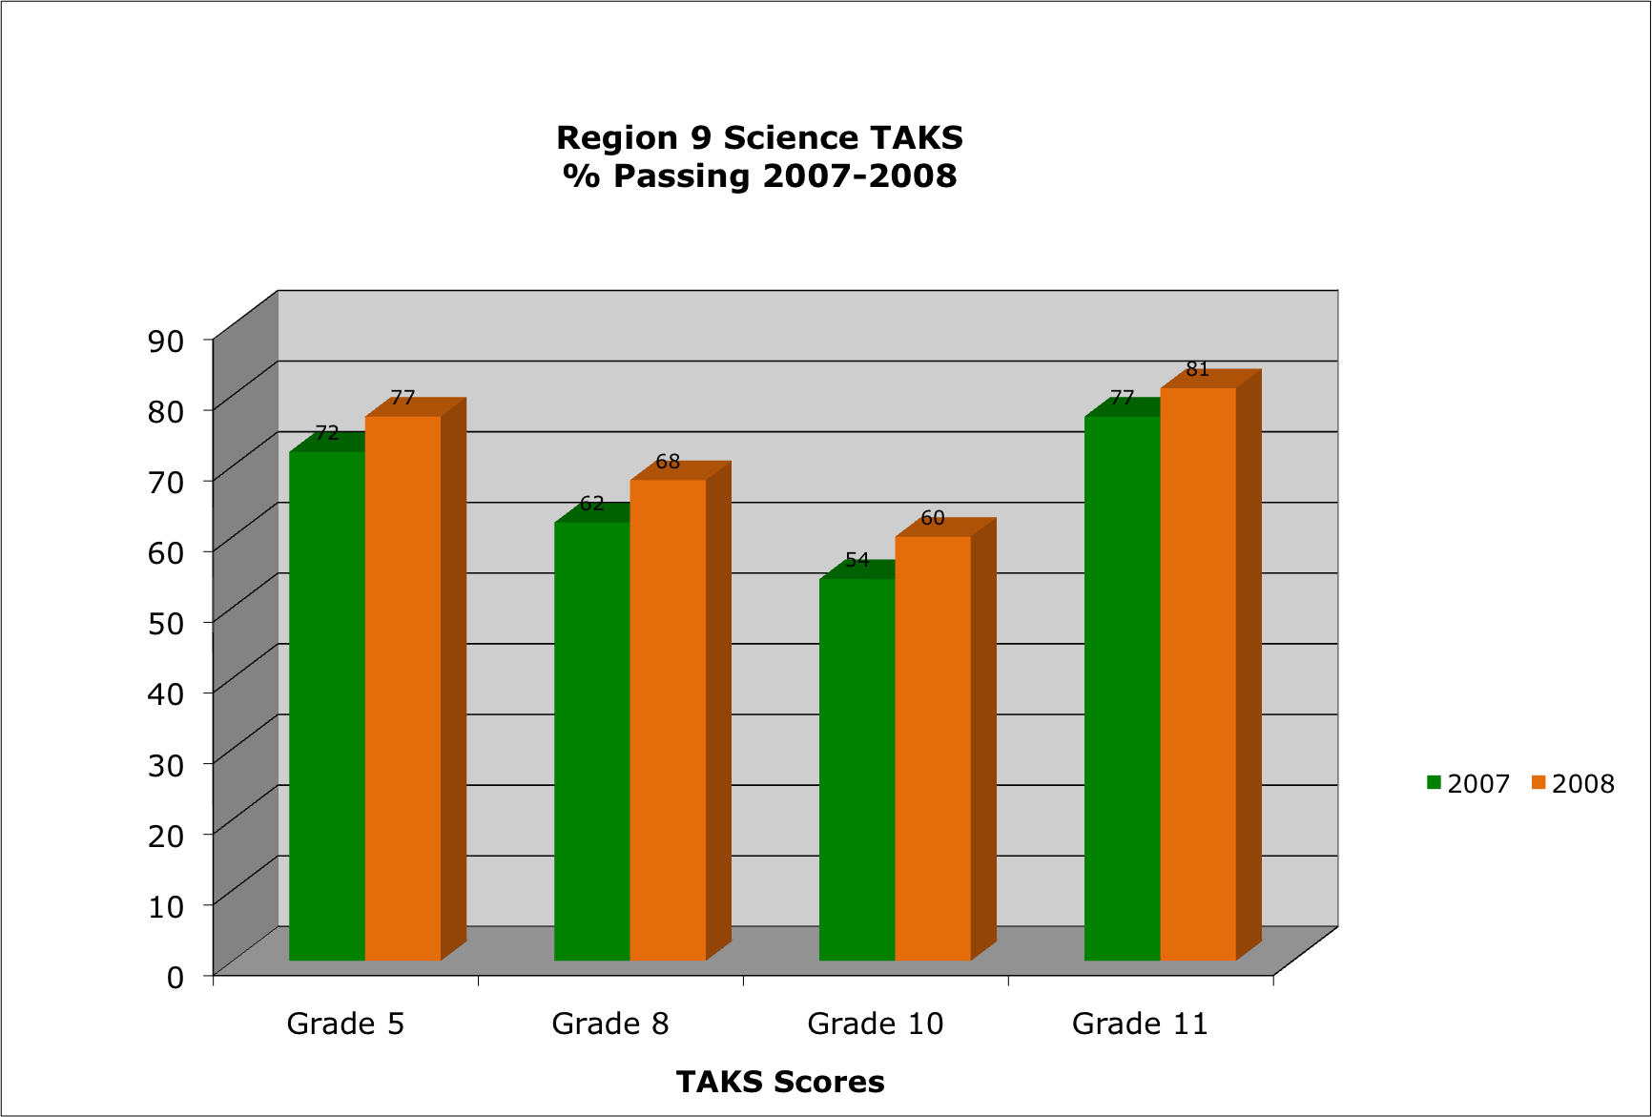
Figure 29. Region 9 Science TAKS

The Region 15 Collaborative compared Science TAKS scores of students for the Grades 5, 8, 10, and 11across 2006-2007 and 2007-2008. There were appreciable gains in Grades 5, 10, and 11. The most appreciable gain (10 percentage points) occurred in Grade 11. Followed by 8 percentage points gain in Grade 5. There was a 7-percentage points gain in Grade 10.

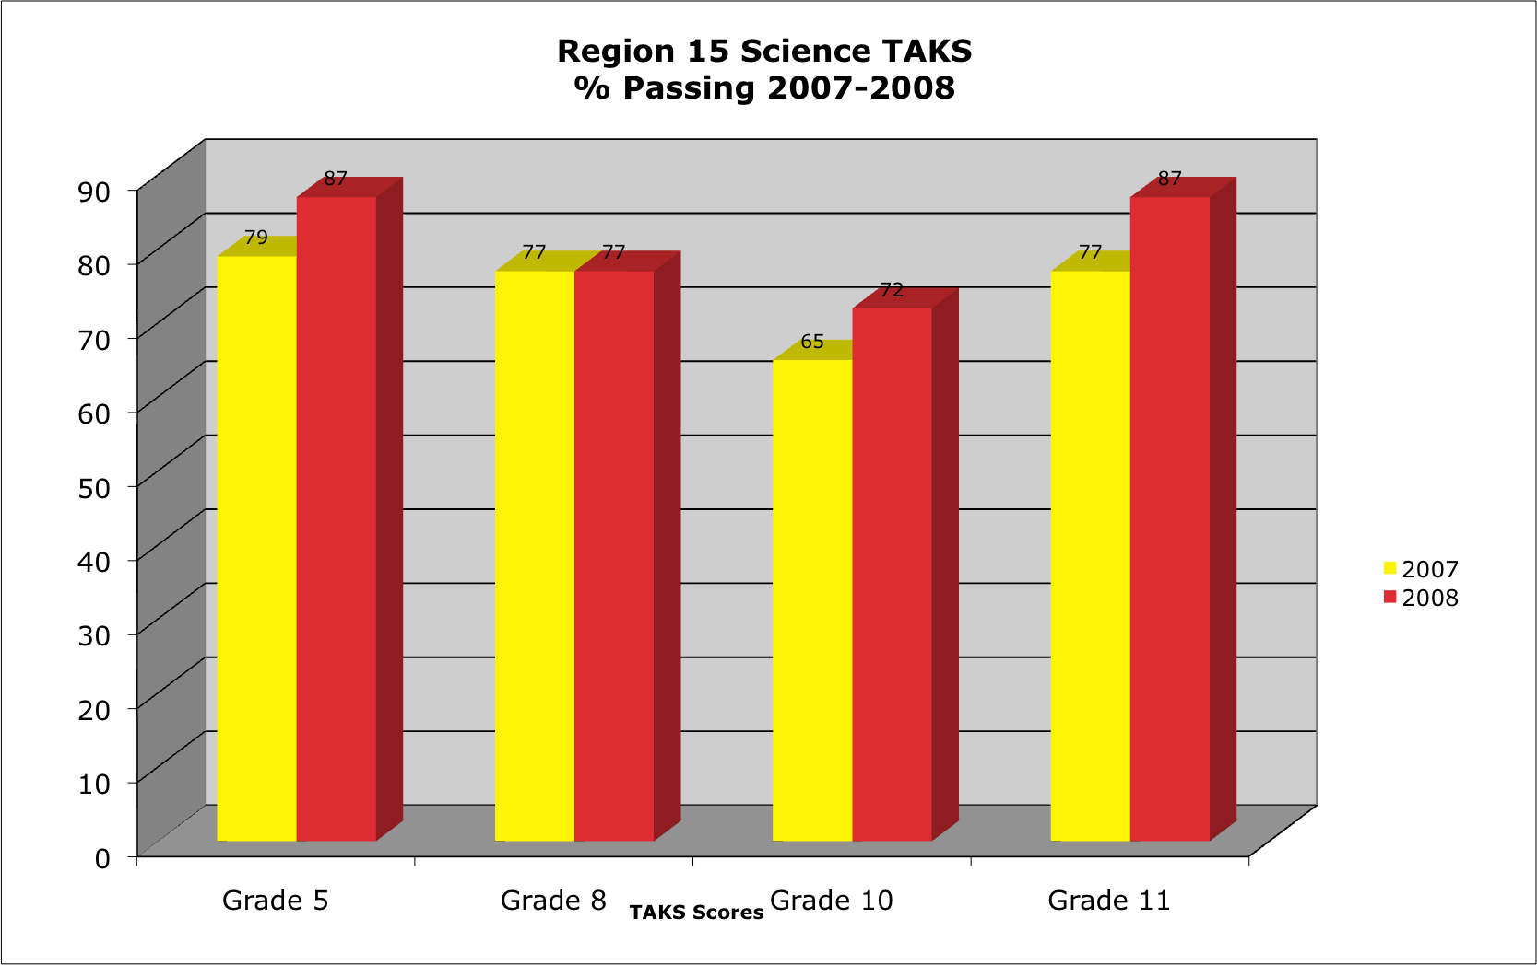
Figure 30. Region 15 Science TAKS

The Region 18 Collaborative compared Science TAKS data for 2006-2007 and 2007-2008 in Grades 5, 8, 10, and 11. There are appreciable gains in the 2007-2008 Science TAKS scores. The most appreciable gain (17 percentage points) occurred in Grade 10. Followed by 12-percentage points increase in Grade 8. There was an 8-percentage points increase in Grade 5 and a 6-percentage point increase in Grade 11.

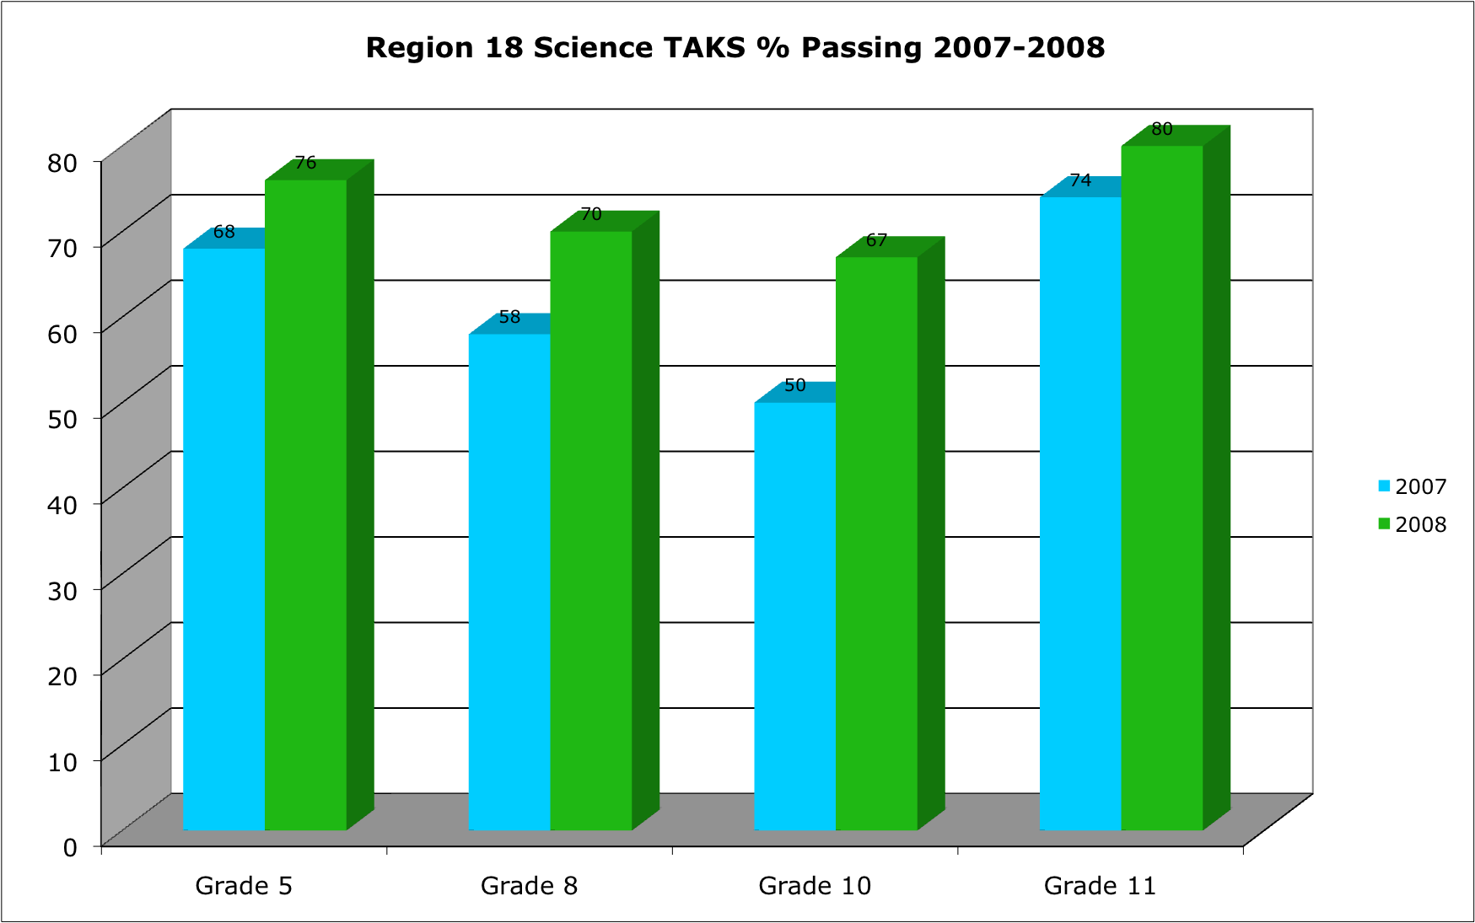

Figure 31. Region 18 Science TAKS

Another challenge in comparing student achievement data in Texas is that since the TAKS was administered in 2003, the standard for passing was gradually increased each year through 2005. Thus, comparisons of the percent passing are hindered by a lack of consistent criteria to define passing. A more valid metric for making longitudinal comparisons would be the scale score for each of these years. Unfortunately, scale score data by campus is not readily available to the public through the Texas Education Agency.

Challenges and Successes

Collaboratives were asked to report any challenges and successes encountered during the program year. Annual reports were reviewed and challenges and successes were analyzed. Several key themes emerged and are listed below.

Challenges

- Teacher recruitment and retention
- Purchasing and ordering equipment. TRC approves equipment but field office does not allow the purchase
- Administrators are reluctant to release teachers for PD
- Obtaining participation from secondary teachers
- Correlating budgets between the TRC office and the field office
- Lack of evaluation and assessment instruments
- Providing classroom support and onsite follow up
- Lack of TOT training
- Obtaining participant data

Successes

- Teachers attributing their success (i.e., improving student TAKS scores) to their participation in the Science Collaborative.
- Increased understanding of the TEKS and content knowledge
- Fostered collaborative relationships/learning community among teachers and the university
- Enhanced teaching strategies
- Collaborative teachers made several professional presentations at CAST and the TRC Annual Meeting
- Graduate courses completed by teachers as a result of being a TRC member.
- Successfully implement the 5E model

Conclusion

The achievements of the Texas Regional Collaboratives for Excellence in Science and Mathematics Teaching during the 2007-08 funding period have been extensive. The TRC increased the number of Science Regional Collaboratives to 37 and added 22 Regional Mathematics Collaboratives across the state. Each Regional Collaborative consisted of a partnership among numerous organizations and stakeholders with a vested interest in quality science instruction including institutes of higher education, school districts, charter schools, private schools, Education Service Centers (ESCs), and business and industry. During the 2007-08 grant period, 46 Institutions of Higher Education partnered with Regional Collaboratives across the state to provide high quality science and mathematics teacher professional development. In addition to these higher education and ESC partners, teachers from 812 school districts and charter schools and 2342 campuses participated in Texas Regional Collaboratives science program. The Mathematics Regional Collaboratives served teachers in 819 districts and charter schools representing 2,158 campuses. During the 2007-08 project year, a total of 7,958 science educators and 8,053 mathematics educators were served by the Texas Regional Collaboratives.

The total number of Science Teacher Mentors served in 2007-08 was 1,329. Each STM received an average of 100 contact hours of professional development. The total number of CMs served was 5,872 with each CM receiving an average of 15 contact hours. The total number of Mathematics Teacher Mentors served in 2007-08 was 8,053. The total number of contact hours provided by the TRC was 246,969. This included college credit hours which many teachers earned through taking coursework at the Institutions of Higher Education listed previously. Based on an average student/teacher ratio of 65.4 students per TRC teacher, approximately 517,270 students have been impacted by TRC professional development. Mathematics teachers averaged 58.1 students per teacher for a total impact of 467,074 students.

Unfortunately, while much has been accomplished by the Texas Regional Collaboratives over the 2007-08 program year, the services provided represent only a fraction of those needed for the 135,000 elementary teachers and the 32,000 secondary science and mathematics teachers in the state. During the 2008-09 grant period, the goal of the TRC will be to continue to scale up its efforts to reach additional teachers while maintaining a focus on the long-term and sustained professional development that is the hallmark of this program.

Appendix

District List

 | Math TRCs | Science TRCs
A+ and Inspired Vision |  | P
Abernathy ISD |  | P
Abilene Christian Schools | P
Abilene ISD | P | P
Academy of Dallas | P
Advantage Academy Charter | P | P
Agua Dulce ISD | P | P
Alamo Heights ISD | P | P
Alba-Golden ISD | P | P
Albany ISD | P | P
Aldine ISD |  | P
Alief ISD |  | P
Aledo ISD | P
Alice ISD | P | P
Alief ISD |  | P
Allen ISD | P | P
Alpine ISD | P | P
Alto ISD | P | P
Alvarado ISD | P | P
Alvin ISD |  | P
Alvord ISD | P | P
Amarillo ISD |  | P
Ambassadors Preparatory Academy |  | P
American Youthworks Charter | P
Amherst ISD | P | P
Anahuac ISD | P
Anderson-Shiro ISD | P
Andrews ISD |  | P
Angleton ISD |  | P
Anna ISD | P
Anson ISD | P | P
Anthony ISD |  | P
Anton ISD |  | P
Apple Springs ISD | P
Aransas County ISD | P | P
Aransas Pass ISD | P | P
Archdioscese of Galveston/Houston |  | P
Archdiocese of San Antonio |  | P
Archer City ISD | P
Arlington Classics Academy | P
Arlington ISD | P | P
Arp ISD | P
Aspermont ISD | P | P
Athens ISD | P | P
Atlanta ISD | P | P
Aubrey ISD | P
Austin ISD | P | P
Austin Discovery School |  | P
Austwell-Tivoli ISD | P
Avalon ISD | P
Avery ISD | P | P
Avinger ISD | P | P
Axtell ISD | P | P
Azle ISD | P
Azleway Charter | P
Baird ISD | P
Ballinger ISD |  | P
Balmorhea ISD |  | P
Bandera ISD | P | P
Bangs ISD | P
Banquete ISD | P
Barbers Hill ISD |  | P
Bastrop ISD |  | P
Bay City ISD |  | P
Beaumont ISD | P | P
Beeville ISD | P | P
Bellville ISD | P | P
Belton | P
Ben-Bolt ISD | P
Benavides ISD | P | P
Benjamin ISD
Bethesda Christian School | P
Big Sandy ISD | P
Big Spring ISD | P | P
Big Springs Charter School
Birdville ISD | P
Bishop ISD | P | P
Blackwell CISD | P | P
Blanco ISD | P
Bland ISD | P | P
Bloomburg ISD | P | P
Blooming Grove ISD | P | P
Blum ISD | P | P
Boerne ISD |  | P
Boles ISD | P
Bonham ISD | P | P
Booker ISD |  | P
Borden County ISD | P | P
Bosqueville ISD | P | P
Bovina ISD | P
Bowie ISD | P | P
Boys Ranch ISD | P
Boys and Girls Clubs of South Central Texas |  | P
Brady ISD |  | P
Brazos River Charter | P
Brazosport ISD |  | P
Breckenridge ISD | P | P
Bremond ISD | P | P
Brenham ISD | P | P
Brentwood Christian School | P
Bridge City ISD | P
Bridgeport ISD |  | P
Brock ISD | P
Bronte ISD | P | P
Brookesmith ISD | P
Brooks County ISD | P | P
Brownsboro ISD | P | P
Brownfield ISD |  | P
Brownsville ISD | P | P
Bruceville-Eddy ISD | P | P
Bryan ISD |  | P
Bryson ISD | P
Buckholts ISD | P | P
Buena Vista ISD | P
Bullard ISD | P
Buna ISD | P
Burkburnett ISD | P | P
Burleson ISD | P | P
Burton ISD | P
Bushland ISD | P
Byers ISD | P
Bynum ISD | P
Calallen ISD | P | P
Caldwell ISD |  | P
Calhoun County ISD | P | P
Callisburg ISD | P | P
Calvert ISD
Cameron ISD | P
Canadian ISD | P
Canton ISD | P
Canutillo ISD |  | P
Canyon ISD | P
Carlisle ISD | P | P
Carrizo Springs ISD | P
Carroll ISD | P
Carrollton-Farmers Branch ISD |  | P
Carthage ISD | P | P
Catholic Diocese | P
Cedar Crest Charter School | P
Cedar Hill ISD | P | P
Celeste ISD | P | P
Celina ISD |  | P
Center ISD | P | P
Center Point ISD | P | P
Central Heights ISD | P
Central Texas College Planetarium |  | P
Centerville ISD |  | P
Centerville (Leon) ISD | P
Centerville (Trinity) ISD | P
Channelview ISD |  | P
Channing ISD | P
Chapel Hill ISD | P | P
Cherokee ISD |  | P
Charlotte ISD | P
Chester ISD |  | P
Chilton ISD | P
Chillicothe ISD |  | P
China Spring ISD |  | P
Chisum ISD | P | P
Christoval ISD | P | P
Cisco ISD | P | P
City View ISD | P | P
Clarendon ISD | P
Clarksville ISD | P | P
Claude ISD | P
Clear Creek ISD |  | P
Cleburne ISD | P
Cleveland ISD |  | P
Clifton ISD | P | P
Clint ISD |  | P
Clyde CISD | P | P
Coahoma ISD |  | P
Coldspring-Oakhurst CISD |  | P
Coleman ISD | P | P
College Station ISD |  | P
Collinsville ISD | P
Colmesneil ISD | P
Colorado ISD | P | P
Columbus ISD |  | P
Comal ISD |  | P
Comanche ISD | P | P
Comfort ISD | P
Community ISD | P
Como-Pickton CISD | P | P
Comstock ISD | P
Connally ISD | P | P
Conroe ISD |  | P
Coolidge ISD | P
Cooper ISD | P | P
Coppell ISD | P
Copperas Cove ISD | P | P
Corpus Christi ISD |  | P
Corrigan-Camden ISD | P
Corsicana ISD | P | P
Cotton Center ISD | P | P
Cotulla ISD |  | P
Covington ISD | P | P
Crandall ISD | P | P
Crane ISD | P | P
Cranfills Gap ISD | P | P
Crawford ISD | P
Crockett ISD | P | P
Crockett County CCSD | P
Cross Plains ISD | P
Cross Roads ISD | P | P
Crosby ISD |  | P
Crosbyton ISD |  | P
Crowell ISD | P | P
Crowley ISD | P | P
Crowley-Nazarene Christian | P
Crystal City ISD | P
Culberson County - Allamoore ISD | P | P
Cumberland Academy |  | P
Cumby ISD | P | P
Cushing ISD | P
Cypress-Fairbanks ISD |  | P
Daingerfield-Lone Star ISD | P | P
Dalhart ISD | P | P
Dallas Cty. Juv. Justice Charter Sch. | P
Dallas ISD | P | P
Damon ISD | P | P
Darrouzett ISD |  | P
Dawson ISD | P | P
Dayton ISD | P | P
Decatur ISD |  | P
Deer Park ISD |  | P
DeKalb ISD |  | P
De Leon ISD | P | P
Del Valle ISD | P | P
Denison ISD | P
Denton ISD | P | P
Denver City ISD |  | P
DeSoto ISD | P | P
Detroit ISD |  | P
Devine ISD | P | P
Deweyville ISD | P | P
Dickinson ISD |  | P
Dilley ISD |  | P
Dimmitt ISD | P
Diocese of Amarillo | P
Diocese of El Paso |  | P
Diocese of Corpus Christi |  | P
Diocese of Ft. Worth |  | P
Diocese of Victoria |  | P
Dodd City ISD | P
Donna ISD | P | P
Dr. ML Garza Gonzalez Charter | P
Dripping Springs ISD | P
Driscoll ISD | P
Dublin ISD | P
Eagle Academies | P
Eagle Academy of Fort Worth | P
Eagle Mountain-Saginaw ISD | P | P
East Bernard ISD | P
East Central ISD | P | P
East Fort Worth Montessori |  | P
East Texas Charter School | P
East Texas Christian Academy | P
Eastland ISD | P | P
Ector County ISD | P | P
Ector ISD | P
Edcouch-Elsa ISD | P | P
Eden CISD | P
Edgewood ISD | P | P
Edinburg CISD | P | P
Edna ISD |  | P
Ehrhart School | P | P
El Campo ISD |  | P
El Paso ISD |  | P
Electra ISD | P | P
Elgin ISD | P
Elkhart ISD | P | P
Elysian Fields ISD | P | P
Ennis ISD | P
EOAC Waco | P
Epiphany Episcopal School | P
Era ISD |  | P
Erath Excels | P
Etoile ISD | P
Eula ISD | P | P
Eustace | P
Evansdale ISD | P | P
Everman ISD | P
Fabens ISD |  | P
Fairfield ISD | P | P
Faith Family Academy |  | P
Falls City ISD | P
Fannindel ISD | P | P
Farmersville ISD |  | P
Ferris ISD | P
Flatonia ISD |  | P
Floydada ISD |  | P
Floresville ISD | P | P
Flour Bluff ISD | P | P
Focus Learning Academy | P
Follett ISD |  | P
Forestburg ISD | P
Forney ISD | P | P
Forsan ISD |  | P
Fort Bend Baptist Academy | P
Fort Bend ISD |  | P
Fort Davis ISD | P | P
Fort Elliott CISD | P
Fort Sam Houston ISD | P
Fort Stockton ISD | P | P
Fort Worth ISD | P | P
Fort Worth Academy of Fine Arts | P
Fort Worth Museum of Science and History |  | P
Franklin ISD | P
Frankston ISD | P
Freer ISD | P
Frenship ISD |  | P
Friendswood ISD |  | P
Friona ISD | P
Frisco ISD | P
Fruitvale ISD |  | P
Gadsden | P
Gainesville ISD |  | P
Galena Park ISD |  | P
Galveston ISD |  | P
Garland ISD | P | P
Garrison ISD | P | P
Gary ISD |  | P
Gateway Charter Academy | P
George West ISD | P
Georgetown ISD | P | P
Gilmer ISD | P | P
Gladewater ISD | P | P
Godley ISD | P
Gold-Burg ISD | P
Golden Rule Charter School |  | P
Goldthwaite ISD |  | P
Gonzales ISD | P | P
Goodrich ISD | P | P
Goose Creek ISD | P | P
Gordon ISD | P
Gorman ISD | P
Grace Community School | P
Grady ISD | P
Graford ISD | P
Graham ISD | P | P
Granbury ISD | P
Grand Prairie ISD | P | P
Grand Saline ISD | P | P
Grandview ISD | P
Grandfalls-Royalty ISD | P | P
Granger ISD | P
Grape Creek ISD | P | P
Grapeland ISD | P
Grapevine-Colleyville ISD | P | P
Greenville ISD | P
Greenwood ISD | P
Gregory-Portland ISD | P | P
Groesbeck ISD | P | P
Groveton ISD | P
Gunter ISD |  | P
Gustine ISD | P | P
Guthrie CSD |  | P
Hale Center ISD | P | P
Hallettsville ISD | P | P
Hallsville ISD | P | P
Hamlin ISD | P | P
Hamilton ISD | P | P
Hamshire-Fannett ISD |  | P
Happy ISD | P
Hardin ISD | P
Hardin-Jefferson ISD | P | P
Harlandale ISD | P | P
Harlingen CISD | P | P
Harmony Science Academy - Lubbock | P
Harmony Science Academy | P | P
Harmony ISD | P | P
Harris County | P
Harrold ISD | P | P
Hart ISD | P | P
Hartley ISD | P
Harts Bluff ISD | P | P
Haskell CISD | P | P
Hawkins ISD | P | P
Hawley ISD | P | P
Hearne ISD | P
Hedley ISD | P
Hemphill ISD | P | P
Henderson ISD | P | P
Henrietta ISD | P
Hereford ISD | P | P
Hermleigh ISD | P | P
Hidalgo ISD | P | P
Higgins ISD | P
High Island ISD | P | P
Highland ISD |  | P
Highland Park ISD |  | P
Hillsboro ISD | P | P
Hitchcock ISD | P | P
Holland ISD | P
Holliday ISD | P
Hondo ISD | P
Hooks ISD | P | P
Houston ISD |  | P
Hosanna Christian Academy | P
Howe ISD |  | P
Hubbard ISD |  | P
Huckabay ISD |  | P
Hudson ISD | P | P
Huffman ISD | P | P
Hughes Springs ISD | P | P
Humble ISD |  | P
Huntington ISD | P | P
Huntsville ISD | P | P
Hurst-Euless-Bedford ISD | P | P
Hutto ISD | P | P
Idalou ISD |  | P
Industrial ISD | P
Ingleside ISD | P
Iola ISD | P
Iowa Park CISD | P
Ira ISD | P | P
Iraan-Sheffield ISD |  | P
Irion County ISD |  | P
IRRA | P
Irving ISD | P | P
Italy ISD | P
Jacksboro ISD | P | P
Jacksonville ISD | P | P
Jasper ISD | P
Jayton-Girard ISD |  | P
Jean Massieu Academy | P
Jefferson ISD | P | P
Jim Hogg Co. ISD | P
Jim Ned CISD | P | P
Joaquin ISD | P
Johnson City ISD |  | P
Joshua Christian Academy | P
Joshua ISD | P
Jourdanton ISD | P
Juan B. Galaviz Charter | P
Jubilee Academic Center | P
Judson ISD | P | P
Juvenile Justice Center |  | P
Karnes City ISD |  | P
Katy ISD |  | P
Kaufman ISD | P
Keller ISD | P | P
Kendelton ISD | P
Kenedy County Wide CSD | P
Kenley Schools | P
Kennard ISD | P
Kennedale ISD | P | P
Kerens ISD |  | P
Kermit ISD | P
Kerrville ISD | P
Kilgore ISD | P | P
Killeen ISD | P | P
Kingsville ISD | P
KIPP Austin College Prep |  | P
KIPP Foundation |  | P
Kirbyville CISD | P | P
Klein ISD |  | P
Klondike ISD |  | P
Kopperl ISD | P
Kountze ISD | P | P
Kress ISD | P
Krum ISD | P | P
La Academia de Estrellas | P
La Escuela De Las Americas |  | P
La Feria ISD |  | P
La Joya ISD |  | P
La Marque ISD |  | P
La Ponte ISD |  | P
La Vega ISD |  | P
La Villa ISD
Lackland ISD
Lago Vista ISD |  | P
Lake Travis ISD |  | P
Lake Worth ISD | P | P
Lamar ISD |  | P
Lamar State College Orange | P
Lampasas ISD | P
Lancaster ISD | P | P
Laneville ISD | P
LaPorte ISD |  | P
Laredo ISD | P | P
Lasara ISD | P | P
Latexo ISD | P
Lazbuddie ISD | P
Leander ISD | P
Leary ISD | P | P
Lefors ISD | P
Leggett ISD | P
Leon ISD | P
Leonard ISD | P
Levelland ISD |  | P
Lewisville ISD | P | P
Lexington ISD |  | P
Liberty-Eylau ISD | P | P
Liberty Hill ISD | P | P
Life School (Oak Cliff) | P
Life School (Red Oak) | P
Lighthouse Charter School | P
Lindale ISD | P | P
Linden-Kildare CISD | P | P
Lindsay ISD | P | P
Lindsley Park Community School | P
Lingleville ISD | P
Little Cypress-Mauriceville CISD | P | P
Little Elm ISD | P | P
Livingston ISD | P
Llano ISD | P
Lockney ISD |  | P
Lohn ISD | P
London ISD | P | P
Lone Oak ISD | P
Longview ISD | P | P
Loop ISD | P | P
Loraine ISD | P | P
Lorena ISD |  | P
Lorenzo ISD |  | P
Los Fresnos CISD | P | P
Lovejoy ISD |  | P
Lovelady ISD | P
Lubbock ISD | P | P
Lubbock-Cooper ISD |  | P
Lueders-Avoca ISD | P
Lufkin ISD | P
Lumberton ISD | P
Lyford CISD |  | P
Lytle ISD | P | P
Mabank ISD | P
Madisonville ISD | P | P
Magnolia ISD | P | P
Mainland Preparatory |  | P
Malta ISD | P | P
Manor ISD | P | P
Mansfield ISD | P
Marble Falls ISD |  | P
Marfa ISD | P
Marietta ISD |  | P
Marion ISD | P
Marlin ISD | P
Martins Mill ISD |  | P
Marshall ISD | P | P
Mart ISD | P | P
Martinsville ISD | P
Mathis ISD | P | P
Maud ISD |  | P
May ISD |  | P
Maypearl ISD |  | P
McAllen ISD | P | P
McCamey ISD | P | P
McGregor ISD | P | P
McKinney ISD | P
McLean ISD | P
McLeod ISD | P | P
McMullen County ISD | P
Meadow ISD |  | P
Medina Valley ISD | P | P
Melissa ISD | P
Memphis ISD | P
Menard ISD | P
Mercedes ISD | P | P
Meridian ISD | P
Merkel ISD |  | P
Mesquite ISD |  | P
Metro Academy of Math and Science | P
Metro Charter | P
Meyer Park ISD | P
Mexia ISD |  | P
Miami ISD |  | P
Midland Christian School |  | P
Midland ISD | P | P
Midlothian ISD | P | P
Midway ISD | P
Milano ISD | P
Mildred ISD | P
Miles ISD | P
Miller Grove ISD |  | P
Millsap ISD | P
Mineola ISD | P | P
Mineral Wells ISD | P | P
Mission CISD | P | P
Monahans-Wickett-Pyote CISD | P | P
Montague ISD | P | P
Monte Alto ISD | P
Montgomery ISD | P | P
Moody ISD | P
Moran ISD | P
Morgan ISD | P
Morgan Mill ISD | P
Morton ISD |  | P
Motley County ISD |  | P
Moulton ISD | P | P
Mount Calm ISD | P
Mt. Pleasant ISD | P | P
Mt. Vernon ISD | P | P
Muenster ISD | P
Muleshoe ISD | P | P
Mullin ISD | P
Mumford ISD |  | P
Munday CISD | P
Murchison ISD | P
Nacogdoches ISD | P | P
Natalia ISD |  | P
Navarro ISD | P | P
Navasota ISD | P
Nazareth ISD | P | P
Nederland ISD | P | P
Needville ISD | P
New Braunfels ISD | P | P
New Boston ISD | P | P
New Caney ISD |  | P
New Deal ISD |  | P
New Diana ISD |  | P
New Frontiers Charter School | P
New Home ISD | P | P
New Summerfield ISD | P
New Waverly ISD | P
Newton ISD | P | P
Nocona ISD | P | P
Normangee ISD | P
North East ISD | P | P
Northeast Texas Community College |  | P
North Forest ISD |  | P
North Hopkins ISD | P | P
North Lamar ISD | P | P
North TX Elem School of the Arts | P
North Zulch ISD | P
Northeast Christian Academy |  | P
Northside ISD | P | P
Northwest ISD |  | P
Northwest Prepatory | P
O'Donnell ISD |  | P
Oakwood ISD | P
Odem-Edroy ISD | P | P
Oglesby ISD | P
Olfen ISD | P
Olney ISD | P
Olton ISD | P | P
Onalaska ISD | P | P
One Stop Multiservice Charter School |  | P
Orange Grove ISD | P
Orangefield ISD | P
Outreach Charter | P
Paducah ISD |  | P
Paint Creek ISD |  | P
Palacios ISD | P
Palestine ISD | P | P
Pampa ISD | P
Panhandle ISD | P
Paradise ISD |  | P
Paris ISD | P | P
Pasadena ISD | P | P
Patton Springs ISD |  | P
Pawnee ISD | P | P
Pearland ISD |  | P
Pearsall ISD |  | P
Peaster ISD | P
Pecos-Barstow-Toyah ISD | P | P
Pegasus School |  | P
Penelope ISD |  | P
Perrin-Whitt CISD | P | P
Perryton ISD | P
Petrolia ISD | P
Pettus ISD | P
Pewitt CISD | P | P
Pflugerville ISD | P | P
Pharr-San Juan- Alamo ISD | P | P
Phoenix Charter School | P
Pine Tree ISD | P | P
Pineywood Community Academy | P
Pittsburg ISD | P | P
Plainview ISD |  | P
Plano ISD |  | P
Pleasant Grove ISD | P | P
Pleasanton ISD | P
Plemons-Stinnett-Phillips CISD | P
Point Isabel ISD | P
Ponder ISD | P
Poolville ISD | P | P
Por Vida Academy |  | P
Port Aransas ISD | P
Port Arthur ISD | P | P
Port Neches-Groves ISD | P | P
Portland ISD | P
Post ISD | P
Poteet ISD | P | P
Prairiland ISD |  | P
Premier High School |  | P
Premont ISD | P | P
Pre-Service |  | P
Prestonwood Christian Academy | P
Priddy ISD | P
Princeton ISD | P
Private School |  | P
Prodigy |  | P
Progresso ISD | P | P
Prosper ISD |  | P
Quanah ISD | P | P
Queen City ISD | P | P
Quinlan ISD | P | P
Quitman ISD | P | P
Radiance Academy | P
Rains ISD | P | P
Ralls ISD | P | P
Ranch Academy | P | P
Randolph ISD |  | P
Randolph Field ISD | P
Ranger ISD | P | P
Rapoport Academy | P | P
Raul Yzaguirre Schools For Success | P
Raymondville ISD | P
Red Oak ISD | P
Red Lick ISD |  | P
Redwater ISD | P | P
Refugio ISD | P | P
Responsive Education | P
Ricardo ISD | P
Rice Academy |  | P
Riesel ISD | P | P
Richard Milburn Academy | P | P
Richards ISD | P
Richardson ISD | P | P
Rio Grande City CISD | P
Rio Hondo ISD | P | P
Rio Vista ISD | P
Rising Star ISD | P
River Road ISD | P
Rivercrest ISD | P | P
Riviera ISD | P
Robert Lee ISD | P | P
Robinson ISD | P | P
Robstown ISD | P
Roby CISD | P | P
Rockdale ISD | P
Rocksprings ISD |  | P
Rockwall ISD | P
Rogers ISD | P | P
Roma ISD | P
Ropes ISD |  | P
Roscoe ISD | P | P
Rosebud-Lott CISD | P | P
Rotan ISD | P | P
Round Rock ISD | P | P
Royse City ISD | P
Round Top-Carmine ISD | P
Royal Independent School District | P
Roxton ISD |  | P
Rule ISD | P | P
Rusk ISD | P
Sabine ISD | P | P
Saint Jo ISD |  | P
Salado ISD |  | P
Saltillo ISD |  | P
Sam Rayburn ISD | P
San Angelo ISD | P | P
San Antonio ISD | P | P
San Antonio Preparatory Academy | P
San Antonio School for Inquiry & Creativity | P
San Augustine ISD | P
San Benito CISD | P | P
San Diego ISD | P
San Elizario ISD |  | P
San-Felipe-Del Rio CISD | P
San Isidro ISD | P
San Marcos ISD | P
San Perlita ISD | P
San Vicente ISD |  | P
Sands CISD |  | P
Sanford-Fritch ISD | P
Sanger ISD | P | P
Santa Fe ISD |  | P
Santa Gertrudis ISD |  | P
Santa Maria ISD |  | P
Santa Rosa ISD | P
Schertz Cibolo Universal City ISD |  | P
Schleicher County ISD | P | P
School of Excellence |  | P
School of Excellence in Education | P
School of Liberal Arts & Science | P
School of Excellence San Antonio |  | P
Scurry-Rosser ISD | P
Seagraves ISD | P
Seashore Learning Center | P | P
Seminole ISD | P | P
Ser Nino Charter School | P
Seymour ISD | P
Shallowater ISD | P | P
Shamrock ISD | P
Sharyland ISD | P | P
Shekinah ISD | P
Shekina and Radiance Academy | P | P
Shekinah Learning Institute | P
Shelbyville ISD | P
Sheldon ISD |  | P
Sherman ISD |  | P
Shepherd ISD | P
Shiner ISD |  | P
Sidney ISD | P
Silsbee ISD | P | P
Silverton ISD | P
Simms ISD | P | P
Sinton ISD | P | P
Skidmore-Tynan ISD | P
Slaton ISD | P | P
Slidell ISD | P | P
Smyer ISD |  | P
Snook ISD | P | P
Snyder ISD | P | P
Socorro ISD |  | P
Somerset ISD | P | P
Somerville ISD | P
Sonora ISD | P | P
South ISD | P
South Plains Academy |  | P
South San Antonio ISD | P | P
South Texas ISD | P | P
South Texas Educational Technologies, Inc. | P
Southland ISD |  | P
Southside ISD | P | P
Southwest ISD | P | P
Southwest Preparatory | P
Spearman ISD | P
Splendora ISD | P | P
Spring ISD |  | P
Spring Branch ISD |  | P
Spring Creek ISD | P
Spring Hill ISD | P | P
Springlake-Earth ISD |  | P
Springtown ISD | P
St. Gregory Catholic School | P
St. James Day School |  | P
St. Mary's Academy Charter School |  | P
St. Mary's Hall |  | P
Stafford MSD | P
Stamford ISD | P | P
Stanton ISD | P
Star ISD | P
Stephenvile ISD |  | P
Stockdale ISD | P
Stratford ISD | P
Strawn ISD | P
Sudan ISD |  | P
Sulphur Bluff ISD |  | P
Sulphur Springs ISD | P | P
Summit International Prep | P
Sundown ISD | P
Sunnyvale ISD | P
Sunray ISD | P
Sweeny ISD | P
Sweetwater ISD | P | P
Taft ISD | P
Tahoka ISD | P
Tatum ISD | P
Taylor ISD | P
Taylor County Learning Center |  | P
Teague ISD | P
Temple ISD |  | P
Tenaha ISD
Terrell County ISD | P
Terrell ISD | P
Texarkana ISD | P | P
Texas AgriLife Extension Center
Texas Boys Choir | P
Texas Can! | P
Texas City ISD |  | P
The University of Texas Elementary Charter School |  | P
Texas Language Charter | P
Texas School for the Deaf | P
The School of Liberal Arts and Science | P
Three Rivers ISD | P
Throckmorton ISD | P | P
Tidehaven ISD |  | P
Timpson ISD | P
Tioga ISD | P
Tolar ISD | P
Tomball ISD |  | P
Treetops School International | P | P
Trent ISD |  | P
Trinity Basin Preparatory | P
Trinity Charter School | P
Trinity ISD | P
Troup ISD | P | P
Troy ISD | P | P
Tulia ISD | P
Tuloso-Midway ISD | P | P
Tyler ISD | P | P
Union Grove ISD |  | P
University Charter School |  | P
United ISD | P | P
Uvalde ISD | P | P
University of Texas - Brownsville | P | P
Valentine ISD | P
Valley Mills ISD |  | P
Valley View ISD |  | P
Van Alstyne ISD | P
Van ISD | P | P
Vega ISD |  | P
Veribest ISD | P
Vernon ISD | P | P
Victoria ISD | P | P
Vidor ISD | P | P
Vysehrad
Waco ISD | P | P
Waco Montessori School |  | P
Wall ISD | P | P
Waller ISD |  | P
Walnut Bend ISD |  | P
Walnut Springs ISD | P | P
Warren ISD | P
Waskom ISD | P | P
Water Valley ISD | P | P
Waxahachie ISD | P
Weatherford ISD | P | P
Wells ISD | P | P
Wellman-Union CISD | P | P
Weslaco ISD |  | P
West ISD | P | P
West Hardin County CISD | P | P
West Orange Cove CISD | P | P
West Oso ISD | P
West Rusk ISD | P | P
Westbrook ISD |  | P
Westphalia ISD |  | P
Westwood ISD | P | P
Wharton ISD | P | P
Wheeler ISD | P
Whitney ISD |  | P
White Deer ISD | P
Whiteface CISD |  | P
Whitehouse ISD | P | P
Whitesboro ISD | P
Whitewright ISD |  | P
Whitharral ISD |  | P
Wichita Falls ISD | P | P
Wildorado ISD | P
Willis ISD | P | P
Wills Point ISD | P
Wilson ISD | P | P
Wimberley ISD | P
Windthorst ISD | P | P
Winfree Academy Charter School | P
Winfield ISD |  | P
Wink-Loving ISD |  | P
Winnsboro ISD | P
Winona ISD | P | P
Winters ISD | P | P
Woden ISD |  | P
Woodsboro ISD |  | P
Woodville ISD | P | P
Wortham ISD | P
Wylie ISD | P | P
Yantis ISD | P
Yorktown ISD | P
Ysleta ISD |  | P
Zapata County ISD |  | P
Zavalla ISD | P
Zephyr ISD | P
ESC Region 1 | P
ESC Region 5 | P
ESC Region 9 | P
ESC Region 12 |  | P
ESC Region 14 | P
ESC Region 16 | P
ESC Region 20 | P

