Conference Attendance Expectations
for Math Teacher Mentors

Conferences provide excellent opportunities for professional development. Quality speakers give numerous presentations. Individual needs are met as participants choose the sessions to attend. The exhibits offer a way to examine available resources and programs. Educators also enjoy the many networking possibilities.

Guidelines if Requesting a Stipend:
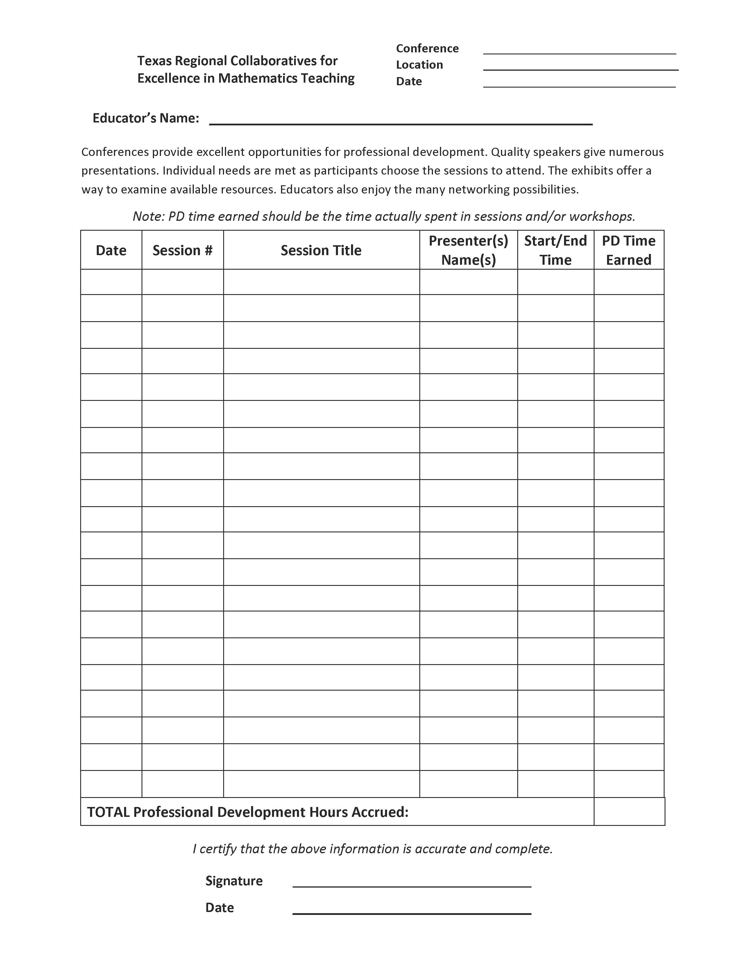
Attend entire conference (all days).
Document sessions attended on form provided.
Submit proper paperwork.
One hour credit may be obtained for visiting exhibits.
Two hours of volunteer time counts.
Cannot be reimbursed by school for any part.
Must have paid for out of pocket initially.

Hours Completed Requirement
7 _______ Conference (7/9)
24 TRC Annual Meeting (24/24)
18 CAMT (18/22)

Note:
If sessions are full, attend general sessions. Stipend is to pay for registration, mileage,
food, and hotel. The allotted amount will only cover if you room, carpool, etc. with
someone. This is an all or nothing arrangement.

