Understanding Plate Tectonic Teacher guide Grade 8

Introduction

Understanding Plate Tectonic

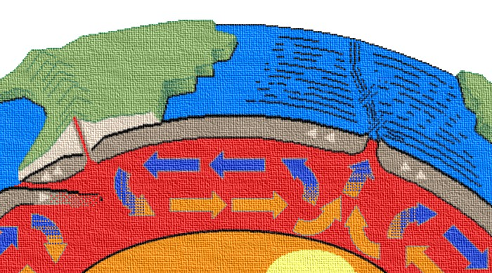

Students will understand the history of Earth, how and why the plates move. Students will do that by observing, predicting and analyzing different situations in this unit. Students will be able to relate the plates’ movements to changes on the Earth surfaces and the formation and disappearing of lands all over the Earth’s crust. Students will be able to predict where the plates might be in the future.

Understanding Plate Tectonic Teacher guide Grade 8

Overview of learning experience

TEKS | 8.14A: predict land features resulting from gradual changes such as mountain building, beach erosion, land subsidence, and continental drift.
Engage | Students observe and analyze the movements of different plates when it collides.
Explore | Students will work with puzzles to observe, analyze and compare their findings to see how continents were once one land form and moved  over million of years to its where it is now.
Explain | Students will collect data on locations of volcanoes and Earth quakes, use it to make tables, and plot these data on the world map.  Compare location of the most recent Earthquakes and volcanoes, and the location of plates’ boundaries.
Elaborate | Students will relate the movement of plates to explain sea floor spreading and the formation of trenches in the oceans
Evaluate | Student will use their understanding of the plates’ movement to create their own booklet that explains what happens when plates collide.

Understanding Plate Tectonic Teacher guide Grade 8

Science Content Standards: 5-8

Earth and Space Science
CONTENT STANDARD D:
As a result of their activities in grades 5-8, all students should develop an understanding of
- Structure of the earth system
- Earth's history
- Earth in the solar system

DEVELOPING STUDENT UNDERSTANDING
A major goal of science in the middle grades is for students to develop an understanding of earth and the solar system as a set of closely coupled systems. The idea of systems provides a framework in which students can investigate the four major interacting components of the earth system--geosphere (crust, mantle, and core), hydro-sphere (water), atmosphere (air), and the biosphere (the realm of all living things). In this holistic approach to studying the planet, physical, chemical, and biological processes act within and among the four components on a wide range of time scales to change continuously earth's crust, oceans, atmosphere, and living organisms. Students can investigate the water and rock cycles as introductory examples of geophysical and geochemical cycles. Their study of earth's history provides some evidence about co-evolution of the planet's main features--the distribution of land and sea, features of the crust, the composition of the atmosphere, global climate, and populations of living organisms in the biosphere.
By plotting the locations of volcanoes and earthquakes, students can see a pattern of geological activity. Earth has an outermost rigid shell called the lithosphere. It is made up of the crust and part of the upper mantle. It is broken into about a dozen rigid plates that move without deforming, except at boundaries where they collide. Those plates range in thickness from a few to more than 100 kilometers. Ocean floors are the tops of thin oceanic plates that spread outward from midocean rift zones; land surfaces are the tops of thicker, less-dense continental plates

Understanding Plate Tectonic Teacher guide Grade 8
TEXAS ESSENTIAL KNOWLEDGE AND SKILLS
Science TEKS:
(8.1)The student conducts field and laboratory investigations using safe, environmentally appropriate, and ethical practices. The student is expected to:
(A) demonstrate safe practices during field and laboratory investigations; and
(B) make wise choices in the use and conservation of resources and the disposal or recycling of materials.
(8.2)The student uses scientific inquiry methods during field and laboratory investigations. The student is expected to:
(A) plan and implement investigative procedures including asking questions, formulating testable hypotheses, and selecting and using equipment and technology;
(B) collect data by observing and measuring;
(C) organize, analyze, evaluate, make inferences, and predict trends from direct and indirect evidence;
(D) communicate valid conclusions; and
(E) construct graphs, tables, maps, and charts using tools including computers to organize, examine, and evaluate data.
(8.3) The student uses critical thinking and scientific problem solving to make informed decisions. The student is expected to:
(A) analyze, review, and critique scientific explanations, including hypotheses and theories, as to their strengths and weaknesses using scientific evidence and information;
(B) draw inferences based on data related to promotional materials for products and services;

(C) represent the natural world using models and identify their limitations;
(D) evaluate the impact of research on scientific thought, society, and the environment; and
(E) connect Grade 8 science concepts with the history of science and contributions of scientists.
8.14A: Predict land features resulting from gradual changes such as mountain building, beach erosion, land subsidence, and continental drift

Understanding Plate Tectonic Teacher guide Grade 8

Interdisciplinary connection

Chemistry
Effect of pressure on the melting point



Physics
Relating friction to earthquakes
Math
Making graphs charts and calculating rate of motion

Plates in Motion

Life Science
Pangaea and fossils’ clues

Technology
Tools scientists use to predict plates’ movement

Understanding Plate Tectonic Teacher guide Grade 8

Interdisciplinary connection

Physics connection: Friction and Earthquakes

Friction is a force that opposes motion of 2 objects in contact in plate movements, blow friction between plates would allow them to slide past one another more freely. High friction opposes this motion causing stresses to build up that leads to Earth quakes.

Chemistry connection: Effect of pressure on the melting point

The melting point of a substance is the temperature at which a solid changes into liquid. Depending on the substance, change in pressure can raise or lower the melting point. A process called decompression melting explains how pressure affects the formation of magma in the mantle.
When very hot but solid rock from the mantle rises, the decrease in pressure allows the rock to melt.

Math connection:

Students can research the Earth quakes in the Pacific North West over the past 100 years and design a graph or chart that might help predict future Earth quakes.

Student can use their math skills to find the rate at which the plates are moving given specific information.
Ex: How many miles would a plate travel in 100 million years at a rate of 1 inch per year?

Understanding Plate Tectonic Teacher guide Grade 8

Interdisciplinary connection Cont.

Life Science connection: Dinosaurs and Pangaea

Before Pangaea broke up, dinosaurs roamed the entire continent. As Pangaea began to break up, the population of dinosaurs were divided and isolated on the new continents. The fossil record indicates that dinosaurs began to evolve divergently as a result. Dinosaurs’ species were very diverse by the time they became extinct, about 65 million years ago.
Teachers can discuss Pangaea and the process of natural selection and ask Students to research different dinosaurs that lived after the breakup of the Pangaea and speculate why these dinosaurs evolved the way they did.

Technology connection: Forecasting Earthquakes

Student can research to find out what tool scientists use to predict where an earthquake might occur and why such predictions are important.
Student should find that a Chinese inventor created a device to register earthquakes as early as A.D. 132. Predicting earthquakes is important for saving lives and properties. Some of the tools scientist use to do this job:
Seismographs: measures seismic waves- vibrations produced when 2 plates grind against each other.
Tiltmeters: measure the rise of tectonic plates along a line fault.
Gravimeter: record changes in gravitational strength caused by rising or falling land.
Laser beam: can detect lateral movements along a fault line.
Satellites: can note the movement of entire tectonic plates.

Understanding Plate Tectonic Teacher guide Grade 8

Rocks and Plate tectonic

Teachers’ Background

In this section, the student is expected to:
8.14A: predict land features resulting from gradual changes such as mountain
building, beach erosion, land subsidence, and continental drift.

What are rocks?
A rock is a mixture of minerals, volcanic glass, organic matter or other materials.
Rocks are classified depending on how they formed into 3 main types:

- Igneous Rocks: Are the type of rocks that form from a cooling magma inside or outside the earth surface. These rocks are classified according to its texture and grain size.
The texture of igneous rock is determined by how fast it cools. The slower it cools the larger the crystals.

- Sedimentary Rocks: forms when sediments are compacted and cemented together. Its classified by the way it forms to 3 main types: chemical, clastic and organic rocks. Sedimentary rocks ca have fossils that gives clues about the age of the rocks.

- Metamorphic Rocks: Are the rocks that form when heat, pressure or fluid acts on igneous, sedimentary or other metamorphic rocks and affect its form or composition. It can have foliated and nonfoliated texture.

Rock cycle is the process in which rocks change slowly over time from one type to another under certain conditions, heat and pressure inside the earth and erosion on its surface.

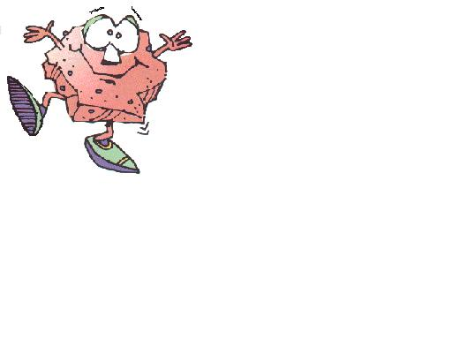

Continental drift

The Continental Drift Theory states that the continents have moved and are still moving today. In 1912 Alfred Wegener introduced this theory, but he did not fully understand what caused the plates to move. A theory is an explanation of a scientific process that has been successfully tested by many different methods. The motion of the Earth's plates help scientists to understand why earthquakes, volcanoes, and mountain building occur.
Scientists believe these plates have been moving for millions of years. In fact, 250 millions years ago the Earth's seven continents were all grouped together into a supercontinent called Pangea.
About 200 million years ago Pangaea covered around 30% of Earth’s surface while a large ocean, Panthalassa, covered the rest of the planet.
Pangaea broke up forming Laurasia and Gondwana, which were separated by the Tethys Sea. Some of the clues on this were:

Fossil Clues: fossils of the reptile Mesosaurus have been found in South America and Africa. Since the reptile couldn’t swim all that distance, Wegener hypothesized that this reptile lived on both continents when they were joined.
Beside reptile, other plants were found in both continents too.
Rock Clues: Similar rocks were found in United States Western Europe, and Greenland. This similarities in rock structure was another evidence of the continental drift.
Climate Clues: Glacial deposits were found in South America, Africa, India and Australia, that’s evidence that continents were connected.

Seafloor Spreading

As the ocean floor slowly separating, new rocks form at the mid ocean ridge.
Mid Atlantic Ridge is getting wider at a rate of 2.5 cm every year. Around 200 million years ago a rift began to form between Greenland and Scotland. This rift led to the formation of North Atlantic, which appeared only 65 million years ago and continued spreading to form the modern Atlantic Ocean.
When the sea floor moves, magma moves upwards and flows from cracks at the mid ocean ridge, it cools and form a new sea floor. This theory was supported by the following observations:
- Scientist tested rocks at the mid ocean ridge and away from it and found that the youngest rocks are at the ridge older rocks are away from it.

- Earth has a magnetic field. Magnetic lines run from South to North Pole. Scientists noticed several magnetic reversals in the past. The reversals recorded in rocks forming along the mid ocean ridge.

Tectonic Plates
A theory that combines continental drift and sea floor spreading is the theory of tectonic plates.
Plates are sections of Earth were Earth crust ” lithosphere” and upper mantle” asthenosphere” are broken. Convectional currents in the mantle cause the movement of the plates. Convectional currents are the result of hot less dense rocks moving upwards and cold denser rocks sinking down. Current data showing that plates move at a rate ranging from about 1 cm to 12cm per year.

When plates move around they interact in different ways. Plates might:

1. Converge, which means two plates move toward each other. Usually an oceanic plate converges with a continental plate. Since oceanic plates are less dense than continental plates, ocean plates subducts or go down into the mantle and the area were this happen is known as the subduction zone.

This type of boundary creates a deep-sea trench. At the subduction zone the temperature of the rocks rises and causes them to melt forming magma that is forced upwards creating volcanoes. The Andes mountain range of South America contains many volcanoes that formed at the convergent boundary of the Nazca and South American plates.

2. Collide, where two continental plates collide and push up the crust to form mountain ranges such as the Himalayas. No volcanoes form because there is little or no subduction to have high temperature to melt the rocks.

3. Slide past each other, Transform boundary, where two slides past one another at different rates. When one plate slips suddenly past another plate, Earth quake will occur. The San Andrea Faults part of a transform boundary where the pacific plate is sliding against the North American plate.

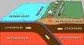

Understanding Plate Tectonic Teacher guide Grade 8

ENGAGE
Teacher can start the lesson by writing the following on the board and ask students to explain what these phrases suggest about Earth?
“Solid as a rock”
“Mountain of strength”
After discussion students can start the following activity:
Snack Tectonic activity
Summary: In this activity the students create a tasty model that illustrates plate tectonic motions. “For more information use the following website: www.windows.ucar.edu”
For more animated plates’ movements students can visit following website: http://www.pbs.org/wgbh/aso/tryit/tectonics/shockwave.html

Materials:
For Each student:
One large graham cracker broken in half
Two 3-inch squares (approx.) of fruit roll up
Cup of water
Frosting
Sheet of wax paper
Plastic knife or spoon
For the class:
Print the directions on overheads (at the bottom of the page) for modeling to students the procedure.

Directions:
Make the model
  - Give each student about a square foot of wax paper and a large dollop of frosting. Instruct students to spread frosting into a layer about half a cm thick.
  - Tell students that the frosting in this model represents the asthenosphere, the viscous layer on which Earth’s plates ride. The plates in this model are represented by fruit roll up (oceanic crust which is thin and dense) and graham crackers (continental crust which is thick but less dense).
- Divergent plate boundary
  - Instruct students to place the two squares of fruit roll up (oceanic plates) onto the frosting right next to each other.
  - Press down slowly on the fruit roll ups (because they are dense and will sink a bit into the asthenosphere) as you slowly push them apart about half a cm.
  - Notice how the frosting is exposed and pushed up where the plates are separated? This is analogous to how magma comes to the surface where real plates are moving apart at divergent plate boundaries. Most divergent plates’ boundaries are located within oceanic crust. When plates begin to pull apart at continents, rift valleys are made, like the Great Rift Valley in Africa, which can become the bottom of the sea floor if the plates continue to pull apart.
- Continental-oceanic collision
  - Instruct students to remove one of the fruit roll ups from the frosting. (They can eat it if they wish!)
  - Tell students to place one of the graham cracker halves lightly onto the frosting asthenosphere next to the remaining fruit roll up piece. The graham cracker represents continental crust, which is thicker and less dense than oceanic crust (fruit roll up). It floats high on the asthenosphere so don't push it down.
  - Gently push the continent (graham cracker) towards the ocean plate (fruit roll up) until the two overlap and the graham cracker is on top. The oceanic plate is subducted below the continental one.
- Continent-continent collision
  - Tell students that they will next model what happens when tow continents collide. Have them remove both the cracker and fruit roll up from the frosting asthenosphere. (Students can eat or discard the fruit roll up.)
  - Place one edge of both crackers into the glass of water for just a few seconds.
  - Place the crackers onto the frosting with wet edges next to each other.
  - Slowly push the graham crackers towards each other.
  - Notice how the wet edges crumple? This is how mountains are made at convergent plate boundaries! When continents move towards each other there is nowhere for the rock to go but up!
- Transform plate boundaries
  - Pick the two crackers up off the frosting and turn them around so that two dry edges are next to each other.
  - Push one cracker past the other to simulate a transform plate boundary like the San Andreas fault!
- Final step: eat all remaining model materials (except, of course, wax paper and plastic utensils
Evaluation: Have students:
- Draw what each situation looks like in cross section (by looking at the edge of their model)
- Summarize what happened.
- Discuss it as a whole class,
- Discuss model limitations.
Overhead transparencies:

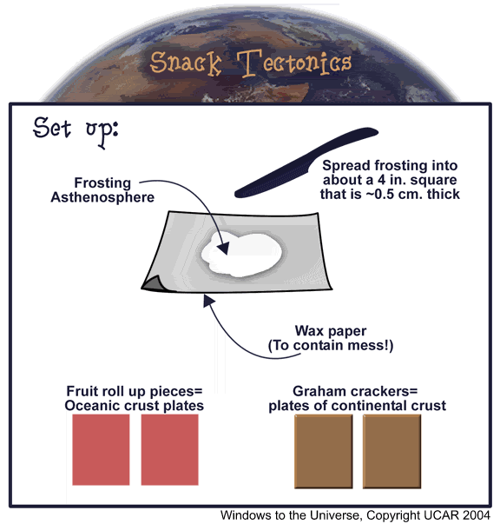

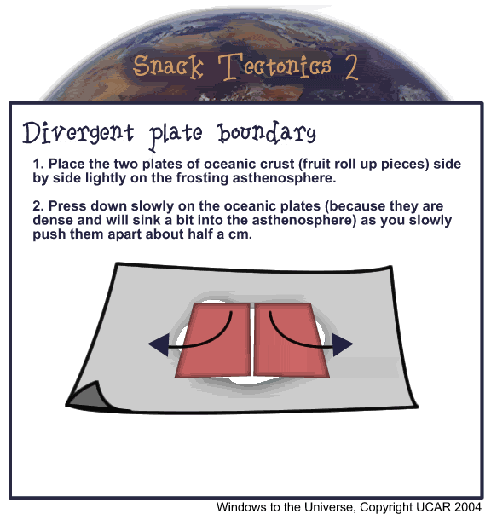

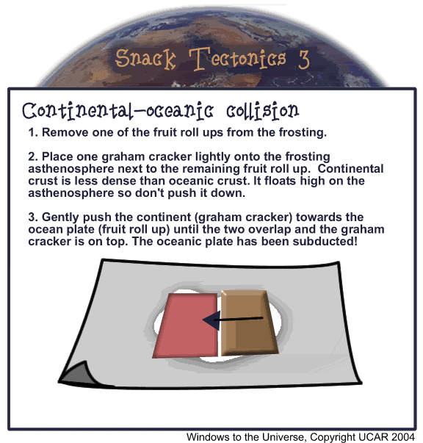

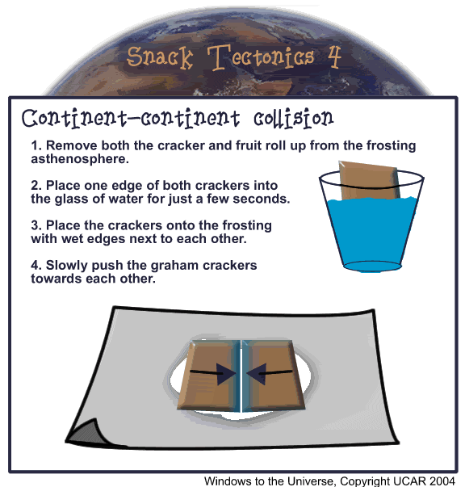

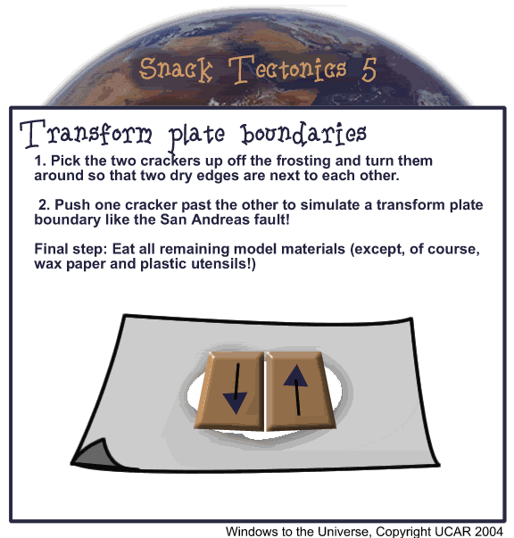

Understanding Plate Tectonic Student page Grade 8

Snack Tectonic Activity

Name:______________________Period:_______Date:___________

Objective: illustrates plate tectonic motions.

Materials:
For Each student:
One large graham cracker broken in half
Two 3-inch squares (approx.) of fruit roll up
Cup of water
Frosting
Sheet of wax paper
Plastic knife or spoon

Procedure:
Follow teacher instruction and pay attention to the overheads

Observations:
- Draw each situation as a cross section by looking at the edge of your model.
- Write a summary under each situation

Divergent boundary Continental oceanic collision

Summary:_________________________ Summary: _______________________

_________________________________ _______________________________

_________________________________ _______________________________

Continent – continent collision Transform plate boundary

Summary:_______________________ Summary:______________________

_______________________________ ______________________________

_______________________________ ______________________________

_______________________________ ______________________________

Write in your own words about the limitation of the models you created?

Understanding Plate Tectonic Teacher guide Grade 8

EXPLORE

Pangaea
(An activity taken and modified from Prentice Hall)
And from http://www.nzitech.net/landforms/two.html-

Objective: Students in groups will examine evidence for the Pangaea theory and use them to reconstruct the supercontinent.
Materials: Each group should get:
Magazines cut out in a bag
Scissors
Glue
Construction paper”If available blue”
Plates cut out in a bag “ or give students the attached map and let them cut it “
Continent map
PART A:
Take the magazine pieces out of the bag and try to fit the pieces together so that they look like the original sheet.
Answer the questions below on your own paper:
- What information did you use to help you fit the pieces together?
Ans.: answers may vary but maybe the shapes and colors of pieces
- Why was it so easy to fit the pieces back together?
Ans.: answers may vary but maybe looking for similarities of color, shapes, shades…etc
3. How would you fit the pieces together if there were no clues to help
you? (What would you look at?)
Ans.: looking at the similarities between edges of pieces.

Part B:
Now each group should get the continent pieces map and the whole continent map. Each group should try to fit the continent in the best way they can. By doing this students are putting together the one landmass the Earth used to have long time ago ”Pangaea”
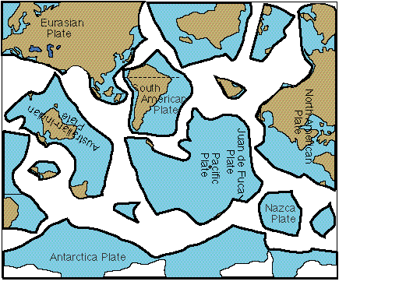
Student should answer the following when they finish:
- What clues other than shape did you use to fit the late pieces together?
Ans : comparing pieces to the ones in continent map.
- What caused the movement of these plates over million of years?
Ans.: Convectional currents in the upper mantle
- How do you think the plates will look like millions o years from now?
Ans.: plates will stay in motion at a low rate, so continent might change locations
- What other evidences scientists use to prove the Continental drift theory?
Ans.: scientists found similar fossils of animals and plants in different continent.
Continent map

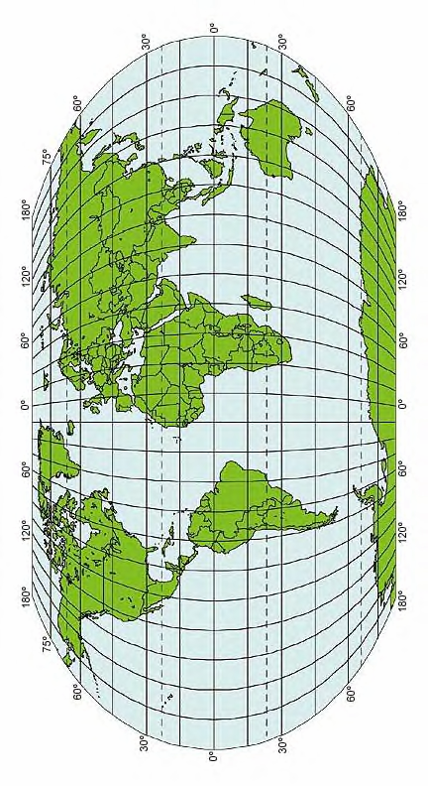

Understanding Plate Tectonic Student Page Grade 8

Pangaea

Name:_____________________period:_______________Date:____________

Objective: Students in groups will examine evidence for the Pangaea theory and use them to reconstruct the supercontinent.

Materials: Each group should get:
Magazines cut out in a bag
Scissors
Glue
Construction paper”If available blue”
Plates pieces map
Continent map
PART A:
Take the magazine pieces out of the bag and try to fit the pieces together so that they look like the original sheet.
Answer the questions below:
- What information did you use to help you fit the pieces together?

- Why was it so easy to fit the pieces back together?

- 3. How would you fit the pieces together if there were no clues to help
you? (What would you look at?)

Part B:
Now each group should get the continent pieces map and the whole continent map. Each group should try to fit the continent in the best way they can
Answer the following when you finish:

- What clues other than shape did you use to fit the late pieces together?

- What caused the movement of these plates over million of years?

- How do you think the plates will look like millions o years from now?

- What other evidences scientists use to prove the Continental drift theory?

- Can you predict what is happening at the plates’ edges that make them stay in motion?

Understanding Plate Tectonic Teacher guide Grade 8

EXPLAIN

Mapping Earth Quakes
Activity adapted from the following websites http://www.coast-nopp.org/resource_guide/elem_mid_school/plate_tectonics_acts/crack.html” and www.lalc.k12.ca.us/target/overview/mapping.html

Objectives: Students will be able to do the following:
- Determine latitude and longitude and plot locations of various volcanoes and earthquakes on a map using a list provided by the instructor.
- Compare student group maps with the locations of the Earth's plate boundaries.
- Discuss the future movement of these plates.
Materials:
- World map with latitude and longitude, one for each student group
- World map with tectonic boundaries, one for each student group
- Table of volcano and earthquake locations (listed by latitude and longitude--developed by student groups)
- Blank transparencies, one per student group
Black, red, blue markers and transparencies each group of students
Procedure:
Before beginning the activity, place students in cooperative learning groups. Have them research the history of volcanoes and earthquakes and determine areas that are currently active. Groups should also develop a class list of earthquakes, and volcanoes including the latitude and longitude of these sites.
- Each student group will plot the positions of each of the earthquakes,and volcanoes on the world maps. Mark the volcanoes with red dots, and earthquakes with blue dots.
- With a different colored marker, the students will trace the plate boundaries on the transparency sheet with the plate boundary map as a base.

Overlay the transparency on the map with the volcanoes and earthquakes.

Student groups observe, analyze, discuss their findings and answer the following:

- Which ocean has a ring of volcanoes around it?

- Where are most of the volcanoes located in relationship to the crustal plates?

- Which volcanoes are not located on the edge of a plate? What might account for the location of these volcanoes?

- Where are most of the major earthquakes in relation ship to the crustal plates?

- What is the relationship between the location of the major volcanoes with the location of the major earthquakes?

- Are mountain ranges located in the area of major earthquake and or volcanic areas?

- Are there any major earthquakes not located on the edge of crustal plates? Can you explain the location of these earthquakes?

- Are all the mountain ranges found along the edge of crustal plates? Explain the location of these mountains.

- Explain why it’s important to know and locate these geologically active areas?

DATA SHEET
MAJOR VOLCANOES*
Volcanos | Name | Longitude | Latitude
A | Aconcagua | 70W | 35S
B | Tungurahua | 80W | 0N
C | Pelee | 61W | 15N
D | Tajumulco | 90W | 15N
E | Popocatepetl | 100W | 20N
F | Lassen | 122W | 40N
G | Rainier | 122W | 47N
H | Katmai | 155W | 60N
I | Fujiyama | 139E | 35N
J | Tambora | 120E | 10S
K | Krakatoa | 108E | 5S
L | Mauna Loa | 155W | 20N
M | Kilimanjaro | 37E | 3S
N | Etna | 15E | 38N
O | Vesuvius | 14E | 41N
P | Teide | 16W | 28N
Q | Laki | 20W | 65N

MAJOR EARTHQUAKES*
Earthquakes | Location | Longitude | Latitude
1 | China | 110E | 35N
2 | India | 88E | 22N
3 | Pakistan | 65E | 25N
4 | Syria | 36E | 34N
5 | Italy | 16E | 38N
6 | Portugal | 9W | 38N
7 | Chile | 72W | 33S
8 | Chile | 75W | 50S
9 | Equador | 78W | 0
10 | Nicaragua | 85W | 13N
11 | Guatemala | 91W | 15N
12 | California | 118W | 34N
13 | California | 122W | 37N
14 | Alaska | 150W | 61N
15 | Japan | 139E | 36N
16 | Japan | 143E | 43N
Students can also log in http://www.iris.edu/seismon/last30days.phtml for more data on Earth quakes.

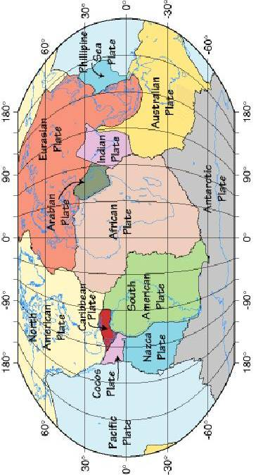

Understanding Plate Tectonic Teacher guide Grade 8

ELABORATE

Sea floor spreading
For more on this activity go to the following website:
http://www.msstate.edu/dept/geosciences/CT/TIG/WEBSITES/RESEARCH/Christine_Oxenford/lesson2.html

Objective
Students will construct a paper model to illustrate how the seafloor is created at mid-ocean ridges and is removed where it descends into trenches.
Materials
For each pair of students:
- one copy of the sea-floor spreading model pattern “ attached”
- scissors
- colored pencils (orange, yellow, green, blue)
- tape
Student Procedures
- Cut along the dotted lines of the sea-floor spreading model pattern” attached”
- Color the areas indicated on the two strips with colored pencils.
- Tape together the orange ends of the strips with the colored sides facing each other.
- Thread the two strips through Slit B of the larger sheet. Pull one side down through Slit A and the other through Slit C. (Figure 1)
- Pull the strips through the slits so that the same colors on both strips emerge from Slit B and disappear into Slits A and C at the same time.

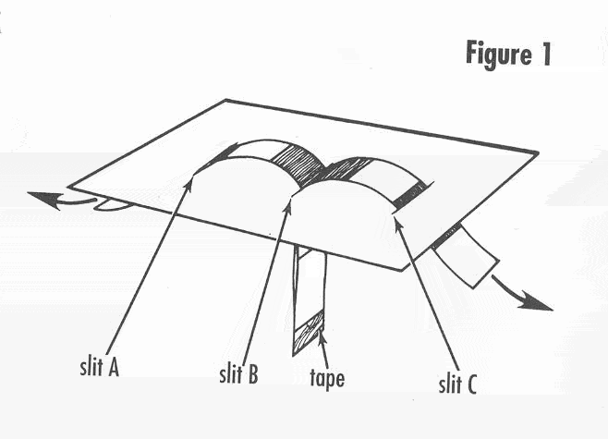
Analyze and Conclude
- What is happening at Slit B? What feature occurs at the corresponding location on the seafloor?
- What is happening at Slits A and C? What features occur at the corresponding location on the seafloor?
- If you were to sample and date the rocks along the colored strip starting at Slit B and moving toward Slit A, what change if any would you see in the age of the rocks?
- If you were to sample and date the rocks along the colored strip starting at Slit B and moving toward Slit C, what change if any would you see in the age of the rocks?
- In this model, what do the strips represent? What do the colors represent?
- New seafloor rock is continually being formed at mid-ocean ridges and old seafloor is continually removed at ocean trenches. If the rock on the continents is continually formed but not removed, how would the age of the oldest rocks on the continents compare with the age of the age of the oldest rocks on the seafloor?
- What are the strengths and weaknesses of this model as a model for demonstrating sea-floor spreading?
Answers to Analyze and Conclude:
- Formation of new seafloor (sea-floor spreading, the plates are diverging). A mid-ocean ridge.
- Consumption or removal of old seafloor (the plates are converging, one plate is sinking or subducting under the other). Ocean trenches.
- The rocks would get older (age of rock increases).
- The rocks would get older (age of rock increases).
- The strips represent the plates that make up the seafloor and the colors represent rocks of different ages.
- The oldest continental rock would be older than the oldest rocks on the seafloor.
- Answers will vary but encourage students to evaluate as many aspects of this model as possible.
For more practice students can log on to the following website for animated introduction to plate tectonics: http://www.pbs.org/wgbh/aso/tryit/tectonics/shockwave.html

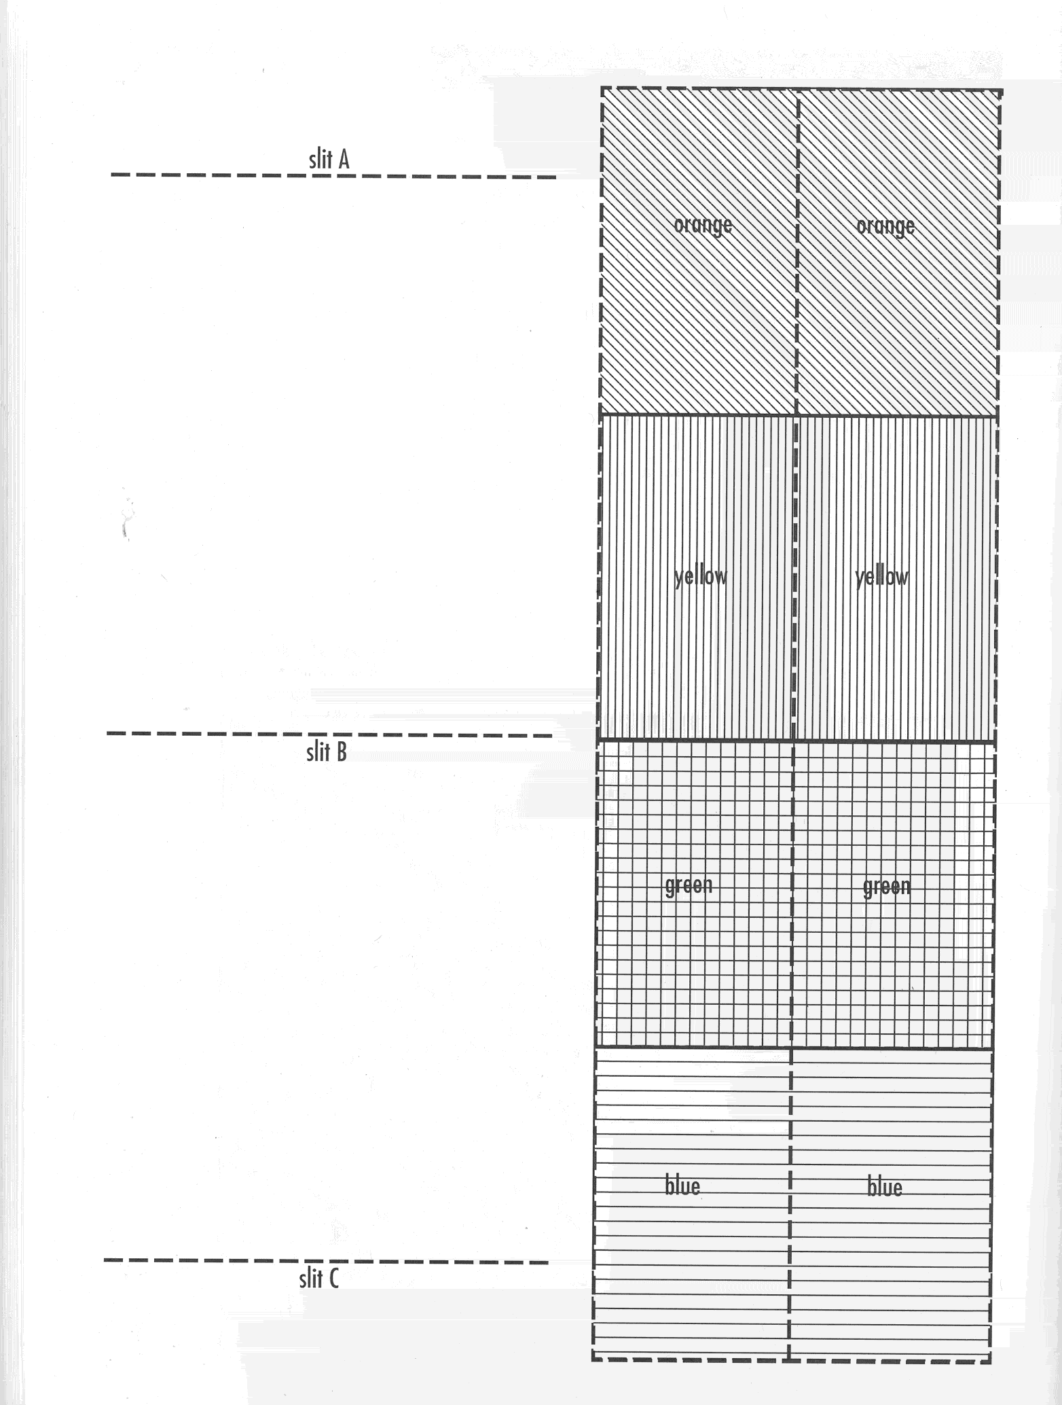

Understanding Plate Tectonic Student page Grade 8

Sea floor spreading

Name:_________________________Period:___________Date:___________

Objective
Students will construct a paper model to illustrate how the seafloor is created at mid-ocean ridges and is removed where it descends into trenches.
Materials
For each pair of students:
- one copy of the sea-floor spreading model pattern “ attached”
- scissors
- colored pencils (orange, yellow, green, blue)
- tape
Procedures
- Cut along the dotted lines of the sea-floor spreading model pattern” attached”
- Color the areas indicated on the two strips with colored pencils.
- Tape together the orange ends of the strips with the colored sides facing each other.
- Thread the two strips through Slit B of the larger sheet. Pull one side down through Slit A and the other through Slit C. (Figure 1)
- Pull the strips through the slits so that the same colors on both strips emerge from Slit B and disappear into Slits A and C at the same time.

Analyze and Conclude
Answer the following:
- What is happening at Slit B? What feature occurs at the corresponding location on the seafloor?

- What is happening at Slits A and C? What features occur at the corresponding location on the seafloor?

- If you were to sample and date the rocks along the colored strip starting at Slit B and moving toward Slit A, what change if any would you see in the age of the rocks?

- If you were to sample and date the rocks along the colored strip starting at Slit B and moving toward Slit C, what change if any would you see in the age of the rocks?

- In this model, what do the strips represent? What do the colors represent?

- New seafloor rock is continually being formed at mid-ocean ridges and old seafloor is continually removed at ocean trenches. If the rock on the continents is continually formed but not removed, how would the age of the oldest rocks on the continents compare with the age of the age of the oldest rocks on the seafloor?

- What are the strengths and weaknesses of this model as a model for demonstrating sea-floor spreading?

Understanding Plate Tectonic Teacher guide Grade 8

EVALUATE

Each student will be asked to make a brochure titled “when plates collide”.
Brochure should include:

- Introduction and description of a landform created when tectonic plates collide.
- A diagram of the process involved in creating the landform
- An example of a place in the world where such landform is found.

Each student will share their brochures with class and be graded from teacher and peers according to the scoring rubrics.

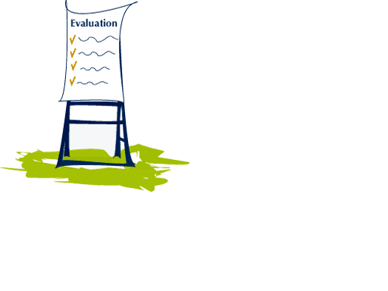
Name: _____________________
Project Title: _____________________ | Teacher(s):
Date: ___________________

When plates collide
Process | Below Avg. | Satisfactory | Excellent
1. Has clear vision of final product | 1, 2, 3 | 4, 5, 6 | 7, 8, 9
2. Properly organized to complete project | 1, 2, 3 | 4, 5, 6 | 7, 8, 9
3. Managed time wisely | 1, 2, 3 | 4, 5, 6 | 7, 8, 9
4. Acquired needed knowledge base | 1, 2, 3 | 4, 5, 6 | 7, 8, 9
5. Communicated efforts with teacher | 1, 2, 3 | 4, 5, 6 | 7, 8, 9

Product (Project) | Below Avg. | Satisfactory | Excellent
1. Format | 1, 2, 3 | 4, 5, 6 | 7, 8, 9
2. Mechanics of speaking/writing | 1, 2, 3 | 4, 5, 6 | 7, 8, 9
3. Organization and structure | 1, 2, 3 | 4, 5, 6 | 7, 8, 9
4. Creativity | 1, 2, 3 | 4, 5, 6 | 7, 8, 9
5. Demonstrates knowledge | 1, 2, 3 | 4, 5, 6 | 7, 8, 9, 10
6. Other: | 1, 2, 3 | 4, 5, 6 | 7, 8, 9

Total Score:____________________________
Teacher(s) Comments:

Powered by TeAch-nology.com- The Web Portal For Educators! (www.teach-nology.com)

Understanding Plate Tectonic Teacher guide Grade 8

Reading connection

How To Dig A Hole to the Other Side of the World
by Faith McNulty;
illustrated by Marc Simont
HarperCollins, New York, NY
(1990; 32 pp.)
Grades K–8
A child takes an imaginary 8,000-mile journey through the Earth and discovers what’s inside. As he passes through the Earth’s crust, then the mantle, and into the core, the book describes the structure of the Earth, the heat energy stored in the center of the Earth, and how far the boy has come and how far he has to go. The reader gains information about the composition of each layer, connections to magma and geysers, and an awesome appreciation of the size of the Earth.

Paperquake
by Kathryn Reiss
Harcourt Brace, San Diego, CA
(1998; 264 pp.)
Grades 5–8
In this interesting blend of mystery and time travel, eighth-grader Violet, a triplet, feels very different from her sisters. In their Victorian home, Violet discovers old letters and a diary from the time of the 1906 San Francisco earthquake. The letters and diary entries, though obviously written in the past, seem to refer to her and incidents in her life. She gradually concludes that she is being sent mysterious messages from the past about how to prevent a tragedy in the future. By closing the gap in the space-time continuum, Violet cleverly prevents disaster just as the Earth’s plates shift to close its gaps.”

Shake, Rattle, And Roll: The World's Most Amazing Earthquakes, Volcanoes, And Other Forces
Author: Spencer Christian and Antonia Felix
Publisher: John Wiley and Sons, 1997
Description: Examines the powerful forces found in Earth, with an emphasis on earthquakes and volcanoes. Includes activities, glossary, and index.
ISBN: 0-471-15291-9

Plate tectonics: The way the Earth works
Written by Kevin Cuff with lan Camichael and Carolyn Willard…Grades 6 - 8

Understanding Plate Tectonic Teacher guide Grade 8

References:
Glencoe Texas Science/ Glencoe McGraw-Hill 2002

Holts Science & Technology 2002

People, places and changes, By Holt

www.teAch-nology.com .- Rubrics

http://www.windows.ucar.edu/teacher_resources/images/snacktect5.gif- Graham cracker activity

www.lalc.k12.ca.us/target/overview/mapping.html- mapping earthquakes and volcaones

http://www.coast-nopp.org/resource_guide/elem_mid_school/plate_tectonics_acts/crack.html -
mapping earthquakes and volcanoes.
http://www.msstate.edu/dept/geosciences/CT/TIG/WEBSITES/RESEARCH/Christine_Oxenford/lesson2.html- sea floor spreading activity

http://www.pbs.org/wgbh/aso/tryit/tectonics/shockwave.html

http://www.nzitech.net/landforms/two.html - Pangaea activity

http://pubs.usgs.gov/gip/dynamic/historical.html - for more activities on Pangaea

http://elu.digitalbrain.com/elu/web/content/content/- on line activities on plate tectonics

http://www.bbc.co.uk/education/rocks/rockcycle.shtml- more activities on plate tectonics

http://www.fossweb.com/modulesMS/EarthHistory/index.html - literature connection references

http://www.lawrencehallofscience.org/gems/PlateTectConx.html- literature connection

http://newton.nap.edu/html/nses/6d.html- science national standards

